Harmonic Oscillator: Activity 1
Characterizing the Period Motion of a Mass on a Spring

Name:______________________ Date:____________ Period:_____

Hypothesis: A mass on a spring can serve as a model system for simple harmonic motion.
Guiding Questions:
Introduction: Periodic motion is initiated when an object is moved away from its equilibrium position and a net force pulls the object back toward its equilibrium position. When the net force is directly proportional to the displacement of the object from the equilibrium position (F = -kx where k is the spring constant and x is the displacement), the result will be simple harmonic motion. Simple harmonic motion is described by two quantities: 1) the period, T, which is the time needed for an object to repeat one complete cycle of motion and 2) the amplitude of motion, which is the maximum distance that the object moves from equilibrium.

- What forces are acting on a mass that is hanging on a spring?

- What can you say about the forces on the mass in its equilibrium position, where the velocity and acceleration are zero?

- Describe what you expect will happen if the mass is moved away from the equilibrium position and released. Use the terms forces, acceleration, velocity, and displacement in your description.

- The period, T, for a simple harmonic oscillator is given by: $T=2π\sqrt{\frac{m}{k}}$
How does the period change as the spring constant increases?
Increases Stays the same Decreases
How does the period change if the mass increases?
Increases Stays the same Decreases
How does the period change over time?
Increases Stays the same Decreases

- Sketch a graph of the displacement of the mass of a simple harmonic oscillator as a function of time for three complete periods. Indicate one period on the graph.
Goals:
- Design an experiment to measure the periodic motion of a mass on a spring and determine if the system is a good model for simple harmonic motion.
- Develop a conceptual understanding of an oscillating system that describes connections between the time varying forces acting on the mass and the resulting acceleration, velocity, and displacement of the mass.
- Explore the graphical representation of an oscillating system and develop an understanding of the amplitude, period, and frequency of a simple harmonic oscillator that will be the foundation of describing waves.
- Explore the potential and kinetic energy of a system undergoing simple harmonic motion.
Instructions:
- Create an experimental “mass on a spring” design using your phone as the mass and a rubber band as the spring. (Students can also use real springs if appropriate springs are available.)

  - Evaluate geometries that will allow the most uniform oscillations along one of the axes of your phone. You may need to investigate several options with rubber bands of different “spring constants”. Describe your design and compare different approaches that you tried that did not produce a stable oscillator. Why did you choose your final design? You might include a picture or a video of the oscillation as part of your description. (Note: Scientists often learn as much by determining why some experiments fail as they learn from experiments that achieve the initially desired outcome. Therefore, it is important to understand and explain why certain experiments did not work as anticipated.)

  - Collect linear acceleration data for >10 oscillations when the oscillations appear “stable” along the axis of interest. Graph the linear acceleration vs time below (note that the amplitude of the oscillations will decay with time).

  - Repeat the experiment for a second oscillator for which the restoring force is different (less or more) than in the first experiment. Provide a graph of your data.
Analysis and Discussion:

- Determine the period for the one of oscillators that you investigated. Begin by measuring the period for each sequential oscillation to determine if the period remains constant over time. Present your data in a table such as the one shown below. The data sampling rate will not necessarily provide you with a measurement at the maximum amplitude for each oscillation. To achieve the best precision, you will need to interpolate from adjacent data points. Describe the method you used to determine the times presented in your table.
Time at Maximum Amplitude (s) | Period (s)
Average =

  - Are the values for the period consistent with what is expected for a simple harmonic oscillator? Explain.

  - Calculate the period for the second harmonic oscillator you investigated. You may assume that it is a simple harmonic oscillator and determine the period by averaging over multiple cycles. Show your calculation so it is clear how you determined the period.

  - Which oscillator had the larger spring constant? Explain.

  - Using your knowledge of the relationship between the period, T, and the frequency, f, write an equation for the frequency of an oscillators in terms of the spring constant and mass of the object.

f =

- Consider the diagram below which shows a simple harmonic oscillator at three different times during a period of oscillation: 1) the equilibrium position, 2) the maximum displacement in the -y direction and 3) the maximum displacement in the +y direction. (Note the phone is upside down in this scenario.)
  - Draw free-body diagrams that represent the forces on the phone for each of the positions.
  - Indicate the value and direction of the acceleration for each position.

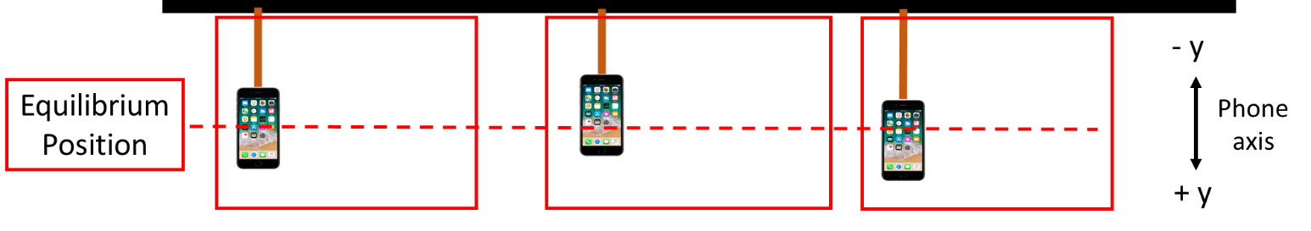

- Using your experimental data for the linear acceleration for one of your experimental conditions, calculate the velocity and displacement of the mass using a spreadsheet. Create a graph that includes acceleration, velocity, and displacement as a function of time. Above the graph, include a diagram showing the position of the phone relative to its equilibrium position (similar that above), which illustrates the correlation of the physical position of the phone with the associated values of acceleration, velocity, and displacement.

- Reproduce the graph of acceleration, velocity, and displacement for two full oscillations. On the graph, mark the times where the kinetic or the potential energy is a maximum.

  - The amplitude of the oscillations decreases over time. Discuss this decrease in amplitude in terms of energy.

  - Provide a hypothesis of why the amplitude decreases as a function of time. Describe an experiment that might be able to test your hypothesis.

Extension Question:
- The data in the following figure was obtained for a spring oscillator with a constant spring constant k. The mass was varied as indicated. Offsets were added to the amplitude values for display purposes.
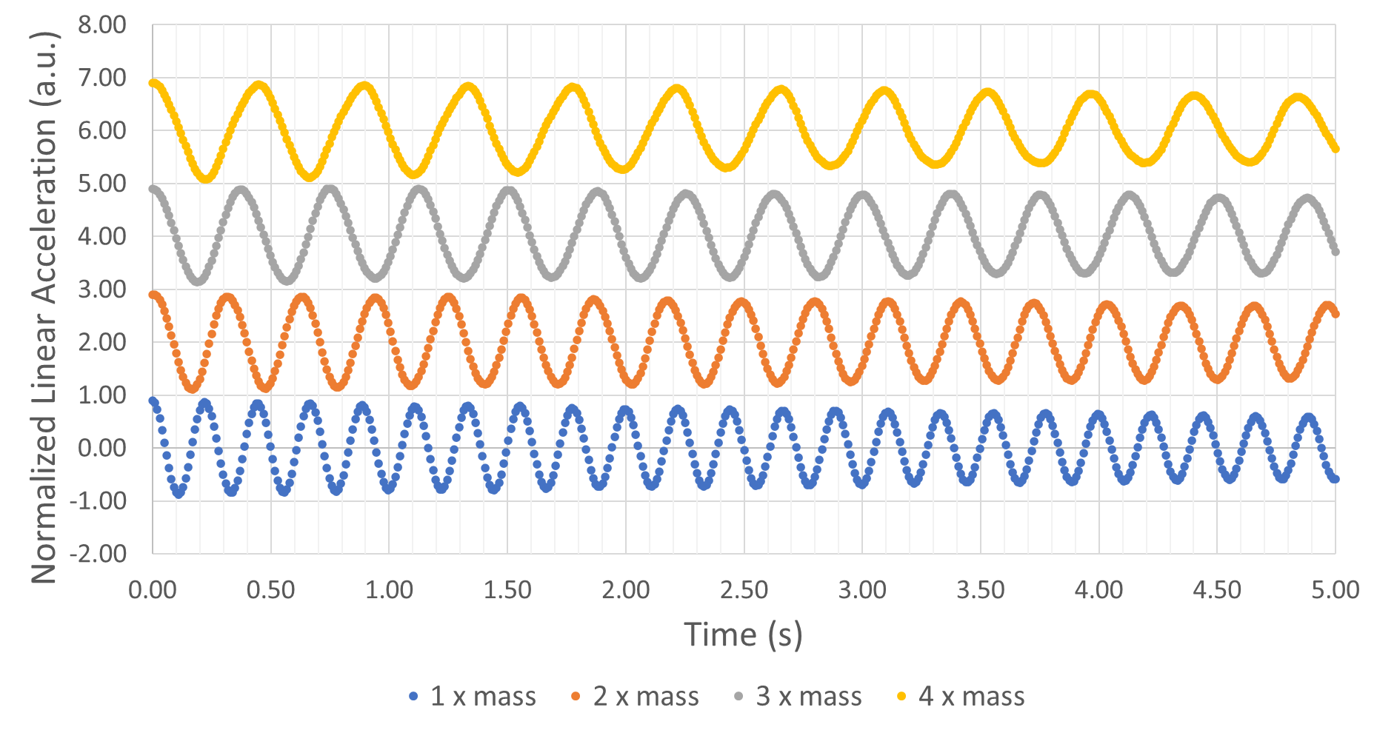
  - Determine the frequencies for the 4 experiments from the graph.

  - Graph the frequency vs mass. Fit the data and determine the relationship between frequency and mass. Show your graph and fit below. Discuss how the results of your fit compares to the formula for the frequency of a simple harmonic oscillator in part 1a.

