Harmonic Oscillator: Activity 2
Simple Bifilar Pendulum: A High Precision Simple Harmonic Oscillator

Name:______________________ Date:____________ Period:_____

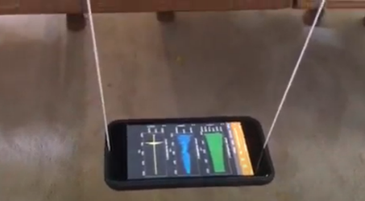
Hypothesis: A simple bifilar pendulum can serve as a model system for simple harmonic motion with minimal damping.

Guiding Questions:
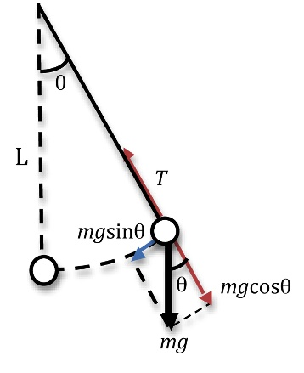
Introduction: Periodic motion is initiated when the bob of the pendulum is moved away from its equilibrium position and a net force pulls the bob back toward its equilibrium position. For small angles of displacement, the period of the pendulum can be shown to be:

$$T=2π\sqrt{\frac{L}{g}}$$

The derivation of this equation is left to the student but can be done using simple algebra, the equation for T from a spring oscillator and by asserting the small angle approximation, sin $θ$ ≈ $θ$. (Note that T is also used for the tension force in the diagram.)

- What force(s) are responsible for the restoring force of a pendulum? (Note: The restoring force is shown in the figure.)

- Answer the following questions about the period of a simple pendulum.
How does the period change as the length of the pendulum increases?
Increases Stays the same Decreases
How does the period change if the mass increases?
Increases Stays the same Decreases
How does the period change over time?
Increases Stays the same Decreases
How would the period change if the pendulum was operating on the moon?
Increases Stays the same Decreases
- Explain how you could determination the value the gravitational constant using a pendulum?

Goals:
- Measure the periodic motion of a simple bifilar pendulum, which behaves as a simple harmonic oscillator.
- Validate the simple equation that describes the motion of a bifilar pendulum.
- Demonstrate the ability to use a simple bifilar pendulum to make a high precision measurement of one of the four fundamental forces, gravity.
- Develop conceptual understanding of an oscillating system that describes connections between the time varying forces acting on the bob and the resulting acceleration, velocity, and displacement of the bob.
- Explore the potential and kinetic energy of a pendulum undergoing simple harmonic motion.

Instructions:
- Construct a simple bifilar pendulum that will allow the pendulum length to be varied (ideally 0.25-1.5 m). A simple bifilar pendulum provides a very stable pendulum for bobs of complex shapes like your phone. The motion and period of a simple bifilar pendulum is described by the same relationship as that of a simple pendulum with a single filar. The details for constructing a bifilar pendulum are provided in Appendix A.

  - Measure the oscillation of the simple bifilar pendulum by collecting linear acceleration data for small angle oscillations, ~ 5 degrees. Use an initial pendulum length of approximately 50 centimeters (measured carefully to 0.1 cm accuracy). Collect linear acceleration vs time for a minimum of 120 seconds of oscillations. Describe your observation and the stability of your pendulum.

  - Repeat the measurement using an initial displacement of ~10 degrees.

  - Collect linear acceleration data for 3 additional lengths of a simple bifilar pendulum using a displacement of <10 degrees. Collect data for a minimum of 40 oscillations. Use lengths between 0.25 – 1.5 m. What general observation can you make about the dependence of the period on the pendulum length?

  - Conduct two additional experiments using bobs with a different mass than the previous experiments. Evaluate different ideas for altering the mass of the bob. Two important considerations: 1) your pendulum length is determined by measuring from the pivot point to the center of mass of the bob, 2) an accurate measurement of the mass is not required, you will only need an estimate of the relative masses. Use pendulum lengths that are different from the lengths used in previous experiments. Describe how the mass of the bob was altered and how you determined the center of mass of the bob.
Analysis and Discussion:

- For the data collecting in Part 1a, determine the period for the pendulum. Provide a graph of linear acceleration vs time showing your data for a minimum of 60 seconds of oscillations.

  - How did you determine that the period of oscillation was constant? Explain. You can use a table if appropriate to illustrate your findings.

  - Compare the period you determined when the pendulum motion was started with different initial displacements. Did you observe a significant difference? Is this consistent with your model? Explain.

- Using the value of period determined from your data and the length of your pendulum, calculate the value of gravitational constant. Present your calculation with appropriate significant figures. Compare your experimental measurement of the gravitational constant to the expected value and report the percentage error of your experiment.

- Using your data for the various pendulum lengths, calculate the period for each experiment. Create a data table that includes the pendulum length, the square root of pendulum length and the period of the pendulum.

  - Create a graph of the period vs the pendulum length and include a best fit to your data.

  - Create a graph of the period vs the square root of the pendulum length. Include a linear fit. Does your fit provide support to the equation describing simple harmonic motion of a pendulum? Explain.

.

- Using the data for one of the pendulum configurations, create a graph of linear acceleration vs time for two full oscillations. Above the graph, indicate the relative positions for the pendulum when the linear acceleration is zero, at a maximum or at a minimum. Also indicate on the graph when the kinetic or potential energy is at a maximum (i.e., all the mechanical energy is either kinetic or potential).

Appendix A

Bifilar Pendulum

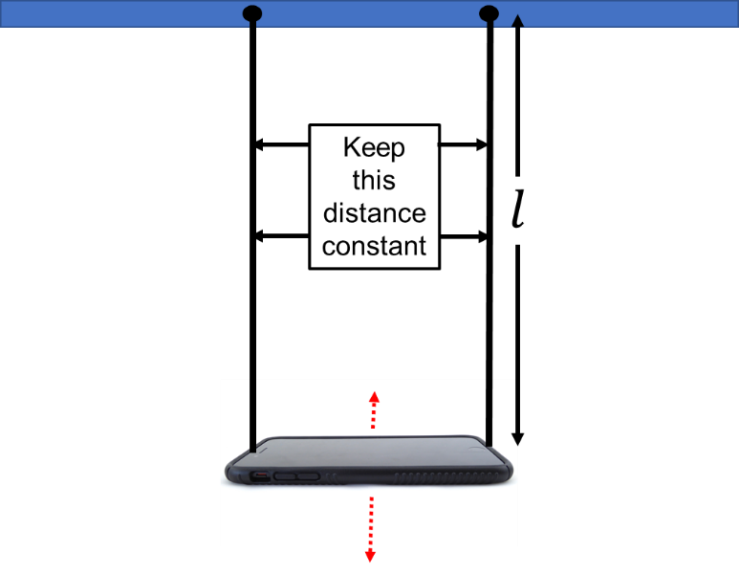
The length of a simple bifilar pendulum is the distance from the point of attachment at the top, to the center of gravity of the bob. In this case, the centerline of the phone will be a good approximation of the center of mass (not the location of attachment to the phone).

Creating a well-defined attachment point as the pivot point for the pendulum enables a more precise determination of length. One option is shown below where the edge of a ruler is used to define the pivot point for the pendulum.
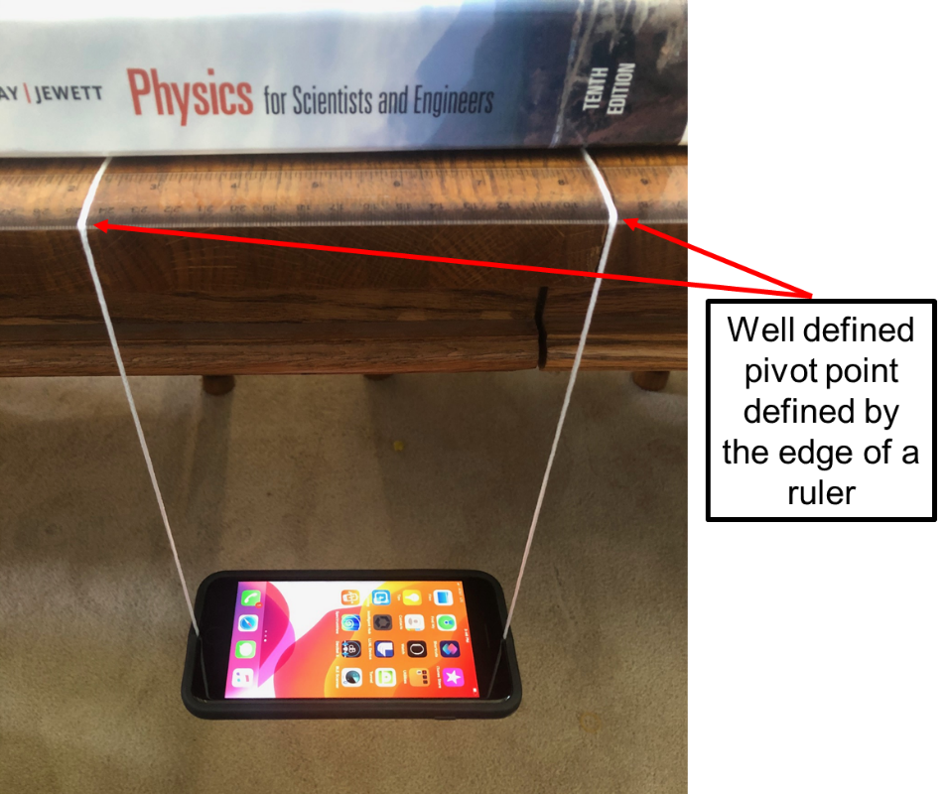

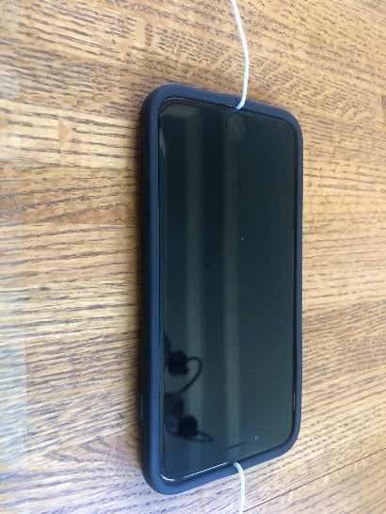
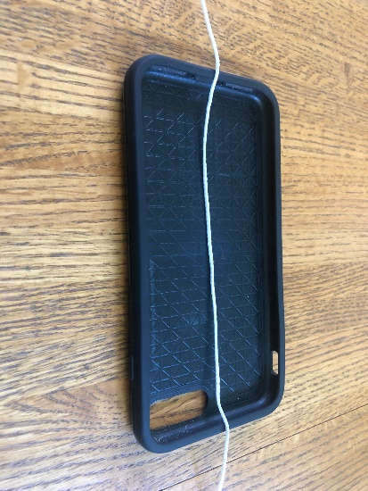
There are several potential ways to attach the string to phone. One is show below with the string looped between the phone and the case. This method requires careful adjustment to maintain balance.

Another option for attachment is to use loops as shown below. It is important to note that the length is still the distance to the center of mass of the phone and not the top of the loop.:
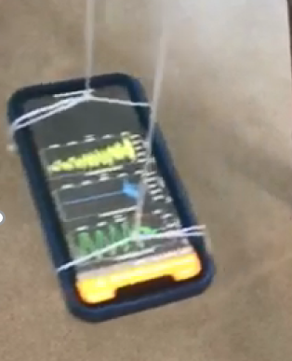

Finally, there are multiple leveling applications that can be used to ensure the phone is level before setting it into oscillation. An example is shown below:
