**Investigating Motion Using GPS**

**Learning Goals**

Upon completion of this lab, students should be able to:

* Explain how reference frames are defined and used to determine relative time and position.
* Describe the differences between vectors and scaler quantities.
* Calculate displacement, distance, velocity, and speed of an object from position data using a spreadsheet.
* Using a spreadsheet, determine the slope of a linear fit to determine rate of change of a variable – in this case velocity from a position vs time graph.
* Demonstrate an understanding of the Earth’s geographical coordinate system by determining the approximate direction of motion (north, south, east, west) from observing the rate of change of latitude and longitude.
* Precisely measure latitude and longitude using the Global Positioning System (GPS) and calculate the change in position in a rectangular coordinate system.

**Introduction**

Understanding motion is a foundational concept not only in physics but also in chemistry and biology, as the universe and everything in it are in constant motion. In this activity, you will explore the basics of motion by measuring position as a function of time. To start, we will examine the simple case of motion along a straight line at constant speed.

To make these measurements, we will use Global Navigation Satellite System (GNSS) technology, a remarkable advancement that combines precise physics principles with sophisticated engineering. GNSS relies on a network of satellites orbiting Earth in exact orbits, each equipped with highly accurate atomic clocks. These satellites send signals via microwaves that can be detected and processed by your smartphone to determine your position on Earth's surface.

GNSS technology has become an integral part of our lives. Many of us rely on it daily for navigation, but its applications go far beyond that. It is used in precision farming, mineral exploration, emergency services, national security, and even wildlife tracking. For example, scientists use GNSS to track animal migration patterns, while emergency vehicles use it for accessing detailed maps and real-time location specific information. Throughout this course, you will learn about the foundational physics principles that make such technologies possible.

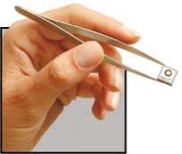As technology becomes more compact and energy-efficient, its potential applications continue to expand, opening new doors to understanding and discovery.

**Pre-Lab Activity (30 minutes)**

1. 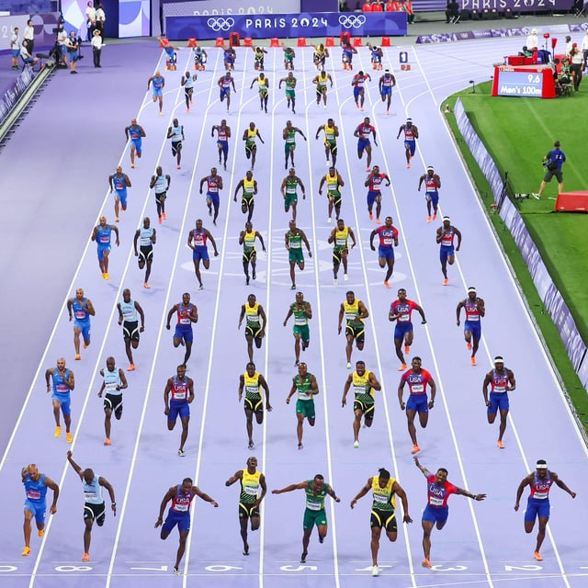Consider the photo of the 100-meter race in the Paris Olympics. Draw a graph that estimates the time and position of the average runner for each of the overlayed frames in this image. In addition, include 4 data points for the 4 seconds prior to the race starting at time=0. In this example, the reference coordinate systems for position is 0.00 meters at the starting line and 100.00 meters at the finish line. The reference coordinate system for time begins at 0.000 seconds at the starting horn. Your graph should be an estimate that shows the general shape of the position vs time graph. (Don’t worry about graphing the exact times or positions.)

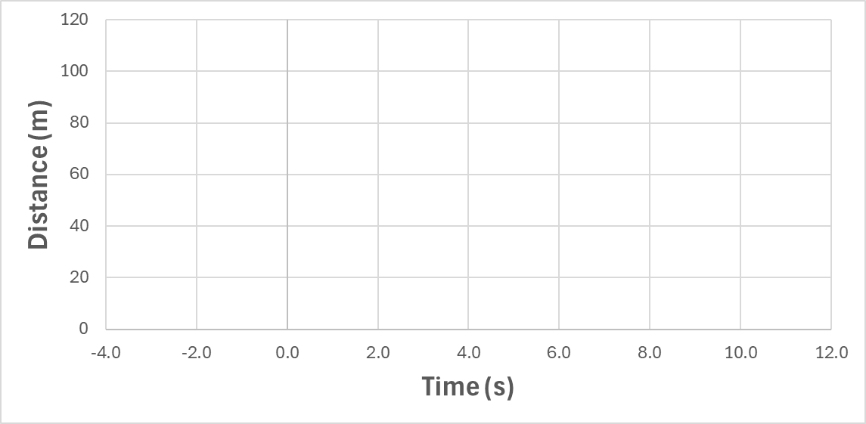

1. Estimate the average velocity of the runners in m/s. Noah Lyles won the Olympic gold medal in the 100 m race with a time of 9.784 seconds, only 0.005 seconds ahead of the next runner.
2. Do you think his velocity at the end of the race was faster or slower than the average velocity? Explain.
3. Refamiliarize yourself with the [geographic coordinate system](https://en.wikipedia.org/wiki/Geographic_coordinate_system). You will want to make sure you understand the terms latitude and longitude. You will also want to become familiar with the general approach to calculating the distance between two points on the Earth's surface, given their latitude and longitude using the [Haversine formula](https://en.wikipedia.org/wiki/Haversine_formula).

Consider using your favorite AI tool to help you explore these two topics via a conversation to help test your understanding. Here is an example prompt: "Explain the geographic coordinate system, including the concepts of latitude, longitude, and how Earth's spherical shape affects these measurements. Provide an overview of how the Haversine formula is used to calculate the shortest distance between two points on Earth's surface using their latitude and longitude. Include a step-by-step breakdown of the formula, an example calculation, and how this applies to real-world scenarios such as navigation or wildlife tracking. After the explaination, please ask me some questions that will help test my understanding."

**Experimental Guide**

**Part 1 (45 minutes): Measuring Latitude and Longitude using GPS**

In this part of the experiment, you will use the phyphox “location” application to measure your location using latitude and longitude coordinates. You will learn to interpret graphs of latitude and longitude as a function of time to determine the direction of motion.

1. Introduction to the geographic coordinate system.

* 1. Estimate the latitude and longitude of your current location using the map provided.

Latitude:

Longitude:

* 1. Measure the latitude and longitude using the phyphox “Location (GPS)” application. Use the “Simple” display mode on phyphox. Report your values using the number of significant figures you believe are appropriate based on the variation of the values displayed by the application. (note the negative sign of the longitude value used to denote Western Hemisphere)

Latitude:

Longitude:

* 1. Which quantity will change if you move in the East or West direction (circle one)?   
      Latitude Longitude
  2. Which quantity will change if you move in the North or South direction (circle one)?  
       
      Latitude Longitude
  3. Based on your current geographic location, which direction would you be moving if you saw a negative change in latitude (circle one)?  
       
      North South East West
  4. Based on your current geographic location, which direction would you be moving if you saw a positive change in longitude (circle one)? (note the negative sign of the longitude value used to denote Western Hemisphere)

North South East West

1. Use the phyphox “Location (GPS)” module to collect data as you walk at a constant pace from point A to point B and back to point A. You do not need to know the exact distance; you will be determining that from your measurement data. (However, if you walk a known distance, it will allow comparison to your results.) A distance of ~100 meters or greater is recommended. For the best results, choose a path where there is not a large change in elevation (no large hills). If you have access to a football or soccer field of known dimensions, that provides a great test location.
   1. Before you go outside, review the instructions below and sketch a graph of your expected position vs. time for the motion you are going to act out while collecting data. What shape do you expect your graph to have? Draw your sketch here and discuss your sketches with your lab partner(s).

* 1. Data collection, walking from A to B and back again:
     1. Let the sensor locate the satellites and refine your starting position at Point A for 20 seconds before you start walking at a constant pace toward point B.
     2. When you arrive at point B, pause for ~10 seconds at point B and then walk back to point A at the same constant pace. (The exact pace is not critical but walking at a constant pace will make data interpretation easier.)
     3. Allow the application to collect ~10 seconds of data at your final location before stopping data collection.
     4. Export your data as an Excel file and email it to yourself for analysis in Part 2.
  2. Take a screenshot of your latitude and longitude graphs on your phone and insert them below.
  3. Based on the change in latitude and longitude that you observed, what can you say about the directions you were walking. Explain.

**Part 2 (120 minutes) – Data Analysis**

In this part of the experiment, you will use your position data measured in the geographical coordinate system of latitude and longitude to calculate distances between locations in rectangular coordinates. While the Haversine formula allows accurate calculation for long distances where the curvature of the Earth is taken into account, we will make a simplification that the Earth’s curvature is small for distances of a few hundred meters. In this case, the distance between two points on the Earth’s surface with a radius, R, simplifies to:

$$Distance =\sqrt{x^{2}+y^{2}} where:$$

$$x=R\left(\frac{π}{180}\right)\left({Lat}_{2}-{Lat}_{1}\right)$$

$$y=R\left(\frac{π}{180}\right)\left({Long}_{2}-{Long}_{1}\right)\cos\left({Lat}_{1}\right)$$

where x and y represent the distances along the legs of a right triangle (North-South and East-West distances) and the Pythagorean theorem is used to calculate the actual distance walked along the hypotenuse. It is useful to note that if you walk along a constant latitude, the x value would be zero. Likewise, if you walk along a constant line of longitude, the y value would be zero.

1. *Two Point Calculation of Distance:* Use the Excel file called “02 Calculating Distance Traveled for Two Point Measurement.xlsx” to perform this analysis. This contains cells with the equations above already set up. If you click on the green cells, you will see the formulas in the formula bar, as shown below.

* 1. Use the spreadsheet to calculate the distance from point A to point B for the data you collected in Part 1. Note that the measurements of the location during the first few seconds of your data collection will vary as the application makes iterations in its algorithm to accurately calculate your position. The time when the position is stabilized should be apparent. Use the “pick data” tool to select a latitude and longitude value for positions A and B and record them here:
* Latitude at Position A:
* Longitude at Position A:
* Latitude at Position B:
* Longitude at Position B:
  1. What distance did you calculate? If your distance was less than 50 meters, go back outside and repeat your experiment to increase the distance to get closer to 100 meters.

1. *Calculation of Displacement as a Function of Time:* Next we want to set up our own spreadsheet to calculate and graph: 1) displacement, 2) total distance traveled, 3) velocity, and 4) speed from our complete GPS data set, so we can determine how each of these variables change as a function of time. As part of this activity, we will review the definitions of each of these quantities and how to calculate them from your data in Excel. We will start with displacement. An example graph for displacement is shown below.

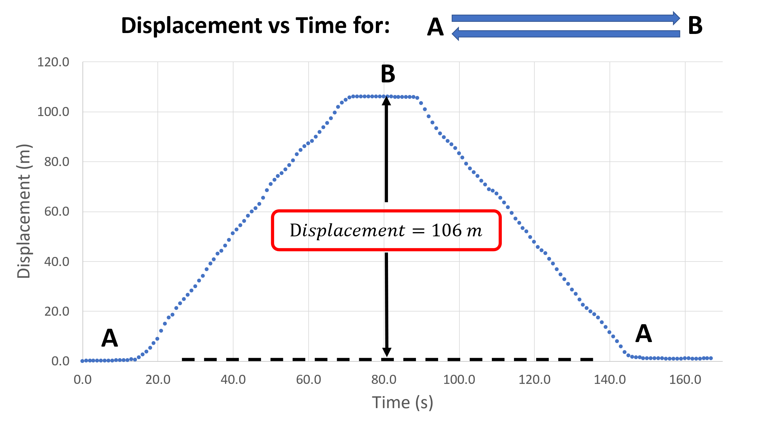

Displacement is a **vector** quantity (with both magnitude and direction) that represents the distance and direction from a given starting point. In the image above, the blue arrows illustrate the movement starting from point A, walking to point B, and returning to point A again. At each moment, the magnitude of the displacement is just the distance from the starting point. Since we are walking along a straight line, the direction of the displacement vector is always directed from point A toward point B and changes in magnitude as a function of time (e.g. the magnitude is 0 m at 10 seconds, 106 m at 80 seconds, 82 m at 100 seconds, and 0 at 160 s).

The following directions provide you with a written guide for calculating the displacement and distance using your spreadsheet. We will also illustrate this in class as a group.

* 1. Open your exported data for your walk between point A and point B. Create a new sheet and call it “Analysis”.
  2. Label the first three columns as shown below. When you collected your data, you waited for 20 seconds before starting to move because the initial measurements of latitude and longitude determined from the satellite signals are not accurate. You will want to ignore the first 10 seconds of your measurement. Copy the “Time (s)”, “Latitude (°)”, and “Longitude (°)” columns from your raw data (not including the first 10 seconds) and paste them into the new sheet so that they are in columns A, B, and C, respectively (it is important that the columns are correct, as the formulas you will input refer to specific columns).  
     Graphical user interface

     Description automatically generated with medium confidence
  3. Create a heading in cell D1 labeled “**x-displacement (m)**” and put a ‘0’ (zero) in D2. Then, create a heading in cell E1 labeled “**y-displacement (m)**” and put a ‘0’ (zero) in E2.  
     Table

     Description automatically generated
  4. Graphical user interface

     Description automatically generated with low confidenceUsing the latitude and longitude calculate the displacement in meters for every time interval. For the displacement along the x direction: In cell D3, type the following (without the quotations) “=D2+6371000*RADIANS(C3-C2)*COS(RADIANS(B3))”. Next, you will hover your cursor over the tiny box in the bottom right corner of D3 (cell D3 must be selected to see it), and click and drag it all the way down to the last line of your data.

This not only copies the formula into all of the cells that you highlighted, but it updates the formula to use the relative cells positions to conduct each calculation. (You can confirm this for yourself.)

* 1. Now do the same for the y-displacement. In cell E3, type the following (without quotations) “=E2+(6371000*RADIANS(B3-B2))” and then drag that formula down to the bottom of your data as before.
  2. Now use the x- and y- values to calculate the total displacement. Create a heading in cell F1 labeled “**Total Displacement (m)**” and put a ‘0’ (zero) in F2.

* 1. Using the Pythagorean theorem we can calculate the displacement and distance along the path we walked using the x and y values. In cell F3, type the following (without quotations) “=SQRT(D3^2+E3^2)” and drag that formula all the way down to the bottom of your data.
  2. You should notice that your displacement should go back to approximately zero, as you returned to your original position. Displacement simply tells you how far away you ended up from your original position. If your ending displacement is large (e.g., greater than a few meters), do the following to see if you’ve made an error:
     1. Double check all of the formulas.
     2. Make sure the formulas updated as you copied them to lower cells.
     3. Make sure you are including all of your data.
     4. Make sure you actually did walk back to your starting position.

* 1. Now create a graph of Displacement vs Time by inserting a scatter chart with “Time (s)” as the x-axis and “Displacement (m)” as the y-axis. Add axis labels with units and include a copy of your nicely formatted graph here.

1. *Calculate Distance as a Function of Time:* The next step in the analysis is to calculate the total distance. Distance is a scaler quantity and only has a magnitude. In order to calculate the distance, we need to take the absolute value of the displacement for every time step. Create a heading in cell G1 labeled “**Total Distance (m)**” and put a ‘0’ (zero) in G2.

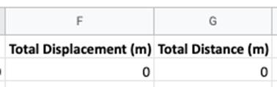

In cell G3, type the following (without quotations) “=G2+ABS(F3-F2)” and drag that formula all the way down.

* 1. Create a graph of Distance vs Time by inserting a scatter chart with “Time (s)” as the x-axis and “Distance (m)” as the y-axis. Add axis labels with units and include a copy of your nicely formatted graph here.

* 1. What is the final value for your distance? ________ m

* 1. How does the distance calculated using this point-by-point method compare to the distance from A to B using a two point calculation using the example spreadsheet?
  2. How does the total distance for the whole trip compare to the distance from point A to point B?
  3. We intentionally walked in a straight line. Do you think our method of measurement would accurately calculate the displacement and distance if we walked in a circle with a radius of 50 meters? Explain.
  4. If you ran quickly in a circle of 5 meters radius, would you still obtain an accurate measurement of the distance you ran? Explain.

1. *Calculate Velocity as a Function of Time:* Velocity is rate of change of the displacement, or $v=∆d/∆t$. Velocity is vector quantity that includes both magnitude and direction. The velocity calculation will include the sign for the displacement. Add column H for the velocity and calculate it in your spreadsheet. Create a scatter chart of velocity vs. time, format it nicely with axis labels including units and paste a copy here.
2. *Calculate Speed as a Function of Time:* Recall that speed is the magnitude of the rate of change of displacement, or $speed=\left|∆d/∆t\right|$. Add column i to your sheet and label it speed, and calculate the speed for each interval using the ABS() function. Create a scatter chart of speed vs. time, format it nicely with axis labels including units and paste a copy here.
   1. The data in both the velocity vs time and the speed vs time graphs appear noisy. Explain why that is the case.
3. What might you do to more effectively illustrate the velocity and speed data that could reduce the large variations in your current graphs.
4. *Calculate the Average Velocity from the Slope of the Displacement (position) vs Time Graph:* In question 2 of this activity, you created a displacement vs time graph. Examine that graph in more detail focusing on the rate of change of position with respect to time. The slope of the graph over a specific “*Δt*” represents the instantaneous velocity. When the position is changing at a constant rate, the slope of the graph will be linear. The slope of a best fit line over a selected measurement period, will provide the average velocity.

* 1. The position at the start of the graph starts at zero and remains zero for a short period of time. The velocity during this time is zero. What is the slope of a best fit line through the data during this time?
  2. Once you start walking, you observe the slope changing at a constant rate. Using your spreadsheet, create a best fit line for the time period where you are walking at constant velocity from point A to point B. (You may want to copy the time and displacement data for that time into a separate sheet to create a best fit line to the data. This can also be done by selecting the cells you want to use for the fit before inserting a trendline.) Insert your graph and best fit line below. Report your velocity.
  3. Repeat this measurement for your walk from point B back to point A. Insert your graph and best fit line below. Report your velocity.
  4. Compare the velocity of your walk in the two directions. Did you walk at the same velocity? Did you walk at the same speed? Discuss.

1. Many companies are now making small “tags” that allow them to be found using Bluetooth (e.g., Apple airtags). Describe a potential application that you would like to implement if miniature GPS tags are developed that could report back real-time position data from any location on the Earth’s surface for extended periods of time?