**Exploring Acceleration and Accelerometers**

**Objectives**

Upon completion of this lab, students should be able to:

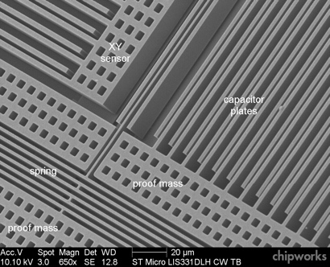

Electron micrograph of a MEMS accelerometer

* Use a MEMS (Microeletromechanical System) 3-axis accelerometer sensor in a smartphone to precisely measure acceleration.
* Qualitatively describe the operational principles of a MEMS accelerometer.
* Qualitatively describe the 1-dimensional motion of a system given an acceleration vs time graph.
* Graphical user interface, text

  Description automatically generatedQuantitatively determine the relative velocity and position of an object at any point in time, given the acceleration as a function of time.
* Explain how accelerometers are used in many mobile health monitoring devices.
* Design a novel experiment to quantitatively characterize the acceleration, velocity, and position of any system undergoing 1-dimensional motion using an accelerometer.

**Introduction**

In this laboratory you will continue your investigation of motion in one dimension. In the previous lab you were introduced to the measurement of **position** for a system with a constant linear **velocity**. In this lab you will extend your investigation of motion by considering systems where the velocity is changing. We introduce the term **acceleration,** which is the rate of change in velocity**.** As part of the laboratory, you will be introduced to the MEMS accelerometer and gain first-hand experience of the incredible applications it enables.

We start with understanding the rate of change relationships that are central to characterizing motion.

$$velocity=\frac{change in position}{change in time}=\frac{ds}{dt}=v acceleration=\frac{change in velocity}{change in time}=\frac{dv}{dt}=a$$

The graphs of position vs time, velocity vs time, and acceleration vs times are all related. If one of these time dependent relationships is known, the other two can be determined. The foundational relationships between position, velocity, and acceleration are captured below:

* The velocity is the slope of the position-time graph
* The acceleration is the slope of the velocity-time graph
* The distance traveled is the area under the velocity-time graph
* The change in velocity is the area under the acceleration-time graph

Historically, the traditional physics student will begin the study of motion by examining a position-time graph as you did in the previous laboratory activity. The velocity is then determined from the rate of change of position and finally the acceleration is determined from the rate of change of velocity. However, it is also possible to start with acceleration and sequentially determine the velocity and then the position of the object. The latter approach becomes particularly useful in today’s technologically advanced world where MEMS accelerometers have become a central component of motion control systems. The ability to precisely measure acceleration using a low cost, compact, and light device, provides a powerful tool for active motion control or passive motion monitoring systems.

The MEMS accelerometers, currently used in phones, provide acceleration measurements at rates of 100 – 800 Hz (depending on your phone model). The change in velocity between each measurement can be estimated using the relationship

$$∆v=a∆t$$

for each sequential pair of data points, where the acceleration is changing slowly compared to the data acquisition rate. Adding up each incremental change in velocity over each sampling interval can provide the “integrated” change in velocity of the system over time. These calculations can be done easily in a spreadsheet.

Similarly, the change in position, can be estimated from the velocity

$$∆s=v∆t$$

Summing each incremental change in position allows the determination of the overall displacement of the object over a given time. You will use this method for calculating the velocity and displacement from the measured acceleration data during this laboratory experiment.

**Pre-Lab Activity (25 minutes)**

As a scientist, engineer, or healthcare professional you should always strive to understand the working principles of any measurement tool that you use. Armed with the knowledge of how the measurement is being conducted helps guide decisions on how to use the tool most effectively and determine the reliability of the data you collect.

1. (20 minutes) In this laboratory you will use a MEMS accelerometer to measure acceleration. Watch the two videos below which describe the working principles of a MEMS accelerometer. The second video provides a bit more detail and also describes how a gyroscope works. We will use gyroscopes in a future laboratory activity.
   1. [How a Smartphone Knows Up from Down (accelerometer) - YouTube](https://www.youtube.com/watch?v=KZVgKu6v808)
   2. [The Micro Mechanisms in Your Phone (youtube.com)](https://www.youtube.com/watch?v=9X4frIQo7x0) (The first ~11 minutes are about accelerometers; the remainder of the video is devoted to the gyroscopes.)
2. A screenshot of a computer

   Description automatically generated with low confidence(5 minutes) Using the figure below and the principles discussed in the videos, describe in your own words how a MEMS accelerometer is able to sense acceleration of your phone.

**Experiment**

**Activity 1 – Exploring the MEMS Accelerometer on your Phone (30 minutes)**

1. Using “acceleration with g”, observe the measured acceleration along different axes as you slowly change the orientation of your phone. Describe your observations.
   1. Using your understanding of a MEMS accelerometer, explain why you measure acceleration due to the Earth’s gravity even when the phone is not accelerating.
2. 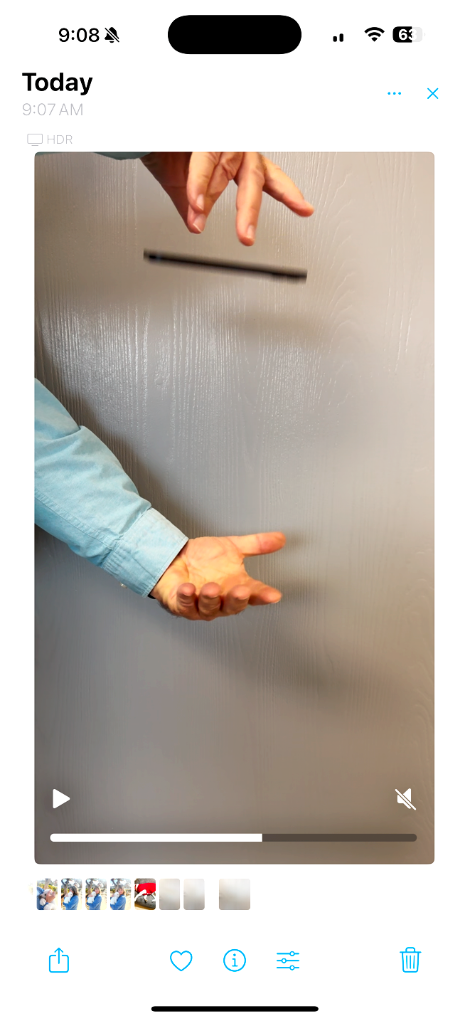Using “acceleration with g”, conduct an experiment to observe the measured acceleration while your phone is in free fall. Measure the acceleration as you drop your phone from one hand to the other, so your phone is in free fall for about 20 centimeters, with the display pointing toward the ceiling. Use the “timed run” function to collect data for 1 second, allowing the measurement of the acceleration for a brief time before and after your phone is in free fall. You may need to do the experiment a few times to time your drop. Insert a screen shot of the three axes view as well as an expanded view of the z-axis data. What is the measured acceleration during free fall? Provide an explanation for your observation.
3. Using “acceleration (without g)”, make simple quick movements along different axes of your phone. Based on your observations, draw a diagram of your phone, and label the x, y, and z axes including the positive and negative directions.
   1. For this next experiment, make sure your orientation lock is not on. Pull up a picture on your phone and hold it up in front of your face. Rotate the phone and observe the transition between portrait and landscape modes. Now set the phone on the table and rotate your phone the same way. Explain why your phone switches between portrait and landscape mode in one case, but not the other.

**Activity 2 – Characterizing a Simple Biomechanical Movement (20 minutes)**

* 1. A person holding a phone

     Description automatically generated with low confidenceConsider the experimental movement shown below where the phone is held with a bent arm at rest before rapidly extending the arm until the phone comes to rest again.
     1. At approximately what time do you predict the velocity will be the greatest?

0.10 s 0.20 s 0.30 s

* + 1. At what time do you predict the acceleration will be positive?

0.10 s 0.20 s 0.30 s

* + 1. At what time do you predict the acceleration will be negative?

0.10 s 0.20 s 0.30 s

* 1. Now conduct the experiment described above and observe the measured acceleration using “acceleration (without g)”. Make a quick smooth motion attempting to direct the motion along one axis. Practice the movement until you get a relatively consistent observation of the acceleration along the direction of motion. Compare your measurement with others as you connect the temporal changes in the measured acceleration with your physical movement. Include a screen shot of your data below and describe how observed changes in acceleration correspond to the motion of the phone at different moments in time.

**Activity 3 – Characterizing the Movement of an Elevator (100 minutes)**

There are on the order of 1 million elevators in the United States that enable approximately 20 billion passenger trips a year. Elevators also provide an excellent opportunity for exploring motion for physics students.

1. This experiment makes use of an elevator. An elevator that travels multiple floors will be ideal. Before making any measurements with your phone sensors, take a ride (up and down) in the elevator while concentrating on the forces you feel during the ride. Discuss what you felt during the ride on an elevator. Did you feel a different force at the start, middle and end of the ride? How did the forces you felt change on the way up compared to the way down?
2. Now use the acceleration (without g) to measure the acceleration during an elevator ride.
   * Determine the orientation of your phone to be used in your experimental design
   * Decide how much data you would like to collect before and after movement to get a baseline of your acceleration measurement
   * Make a measurement (you can choose to measure going up or going down)
   * Capture screenshots of your data (graph of the acceleration along the axis of motion) and export your data for further analysis
   1. Insert a screenshot (or a graph from a spreadsheet) of your acceleration data along the axis of motion. Describe how the different regions of the acceleration data are related to physical movement of the elevator. Discuss what is happening where there are changes in the acceleration and what is happening when the acceleration is zero at different times during the “ride”.

***At this point your instructor will take a moment to describe how to carry out numerical integration using a spreadsheet or may provide you with an example spreadsheet to guide your analysis.***

Review the introduction for the relationship between acceleration and velocity as well as velocity and displacement. In this part of the analysis, you will use *numerical integration* to determine the velocity and the displacement from the acceleration data. Recall that the integral of a function can be determined graphically from the area under a curve. If we break the curve up into small segments, the area under the curve can be approximated as the area of a rectangle around the average height of the two endpoints, as shown in the image below.

1. 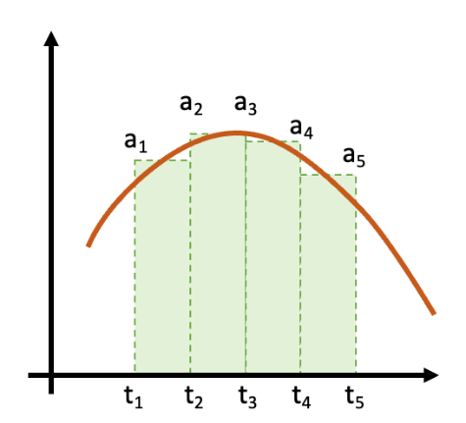Use the image at right to construct a formula for calculating the instantaneous velocity at each point from the acceleration vs time data.
2. Use the formula you created to calculate the velocity at each point in time from the acceleration and time data in the spreadsheet. Create a graph that contains both the acceleration and the velocity as a function of time. Insert the graph below.
3. Calculate the displacement at each point in time from the velocity and time data. Use a similar numerical integration approach as you used to calculate the velocity. Create a graph that contains acceleration, velocity, and displacement as a function of time. Insert the graph below.

**Analysis and Discussion of Activity 3:**

1. Consider your acceleration vs time graph. Sketch what you expect an acceleration vs time graph would look like if you were going in the opposite direction (up or down) from your experiment.
2. Did your data show a period of constant velocity as the elevator traveled between floors? Could you predict the time where the elevator would be traveling at constant velocity by visually inspecting the acceleration vs time graph? Explain.
3. How does the velocity you measured compare to the velocity of other elevators measured by fellow students? Does the value you calculated seem reasonable? Explain.
4. Do you think your calculation of the displacement is accurate? Discuss the process you used to make that evaluation. How might you validate your measurement?

**Activity 4 – Healthcare Applications (20 minutes)**

Consider the recent scientific report outlined below. Conduct an experiment similar to the experimental “test” described in the figure and discuss your observations. You can tuck the phone in your pants or put it in your back pocket.

