**Investigating Forces, Dynamics, and Kinetic Friction**

**Objectives**

Upon completion of this lab, students should be able to:

* Diagram, map

  Description automatically generatedRepresent the relative magnitude and direction of forces using vectors both graphically and algebraically.
* Describe how unbalanced forces acting on an object result in acceleration of the object.
* Summarize the phenomenological force law that can be used to model frictional forces.

Understanding frictional forces is critical in orthopedics and in the replacement of joints.

**Introduction**

Newton’s first law states that any object continues in a state of rest, or of uniform motion in a straight line, unless it is compelled to change its motion by unbalanced forces imposed on it. In the previous laboratory you measured changes in acceleration, but we did not investigate the underlying forces responsible for causing the changes in motion. In this laboratory we will examine the forces. We are able to determine the forces from the measurement of acceleration using Newton’s second law:

$\frac{F}{m}=a$

where the acceleration, ***a***, is directly proportional to the force, ***F***, and inversely proportional to the mass, *m*. (Note the bolded script is used to indicate the variable is a vector.) The system we will study will be acted upon by 6 types of forces at different times during the short experiment:

* Engineering drawing

  Description automatically generatedGravitational

It’s not a stretch to claim that gravity is America’s number one killer, and it is certainly the number one mechanical challenge for life on land.

* Normal
* Applied
* Elastic
* Static Friction
* Kinetic Friction

While all these forces will be acting on the system, this activity is specifically designed to quantitatively measure the force of kinetic friction and determine the coefficient of kinetic friction for specific pairs of surfaces. Kinetic friction is a force that opposes sliding motion between two surfaces. Frictional forces are essential for life and enable us to move around. Without friction between our tires and the road, our cars could not move, and we could not walk without the friction between our feet and the ground. We know these simple actions are much harder if we are driving or walking on ice where the frictional forces are relatively small. The climber in the picture would have a difficult time holding on to the rock without the benefit of frictional forces.

**Pre-Lab Activity (30 minutes)**

1. We just pointed out a few cases where friction is essential. Describe 2 scenarios where low friction is beneficial.
2. In this week’s lab activity, we will be investigating the motion of our phone as it slides on a surface. This [video](https://www.youtube.com/watch?v=IHILOnEW5Qg&list=PLPyapQSxH6maBEwkQ-s33aB3MBwJo24IL&index=87) describes a similar experiment for a sliding hockey puck. In the video, the velocity of the puck is measured. In our case, we will measure the acceleration of your phone. The principles discussed in the video will provide background that will be helpful in interpreting and analyzing the data from your experiment.
3. In your experiment, you will be determining the coefficient of kinetic friction. If you would like a review of frictional forces and the coefficients of kinetic and static friction you can watch the following videos:
   1. [Static and kinetic friction](https://www.youtube.com/watch?v=i-DdiI7gFoM&list=PLPyapQSxH6maBEwkQ-s33aB3MBwJo24IL&index=96)
   2. [Coefficient of friction](https://www.youtube.com/watch?v=QwuldyEP9Jk&list=PLPyapQSxH6maBEwkQ-s33aB3MBwJo24IL&index=97)
4. 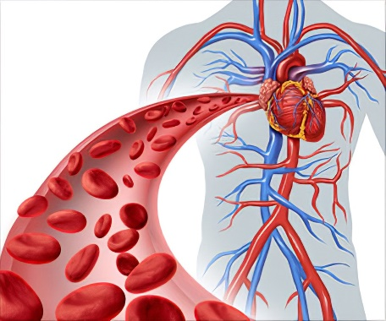Introductory physics classes generally associate friction with forces that oppose motion between two solid surfaces, such as a sliding block on a table. This type of friction arises due to microscopic interactions between surface irregularities. However, friction also plays a critical role in fluids, where it manifests as **viscous resistance**—the force opposing the motion of fluid layers relative to each other or to a solid boundary.

In the context of blood flow, this viscous resistance arises from the internal friction between blood layers (fluid-fluid interaction) and the friction between the outermost layer of blood and the walls of blood vessels (fluid-solid interaction). Blood flow through a vessel can be modeled using principles of fluid mechanics, particularly Poiseuille’s law for laminar flow in cylindrical tubes. We will not derive the equation here, but the relationship helps to understand how the flow through blood vessels is impacted by changes in different variables.

$$Q=\frac{∆P π r^{4}}{8 η L}$$

where:

* *Q* is the volumetric flow rate,
* *ΔP* is the pressure difference between the two ends of the vessel,
* *r* is the radius of the vessel,
* *η* is the viscosity of blood,
* *L* is the length of the vessel

Use your basic understanding of friction and this relationship to answer the following questions.

* 1. Explain how frictional forces between blood and vessel walls affect blood pressure.
  2. 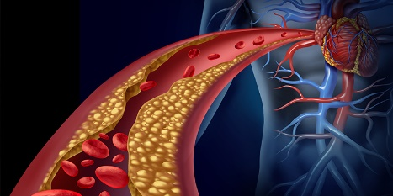In cases of narrowed blood vessels (e.g., due to plaque buildup), how might changes in friction impact the force required to pump blood?

**Experiment**

**Activity 1 – Characterizing the Dynamics of One-Dimensional Motion with Time Varying Forces (120 minutes)**

In this activity you will characterize the movement of an object that is acted upon by multiple forces, some of those forces will vary over the course of the 3 second experiment resulting in changes in the velocity. The three frames below, illustrate the basic experimental design used to create the motion for this investigation.

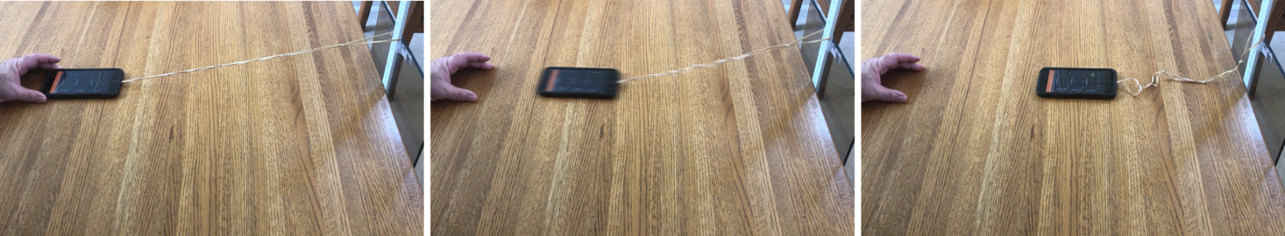

A variable elastic force (a daisy chain of rubber bands) is used to accelerate the phone. The phone will gain momentum and after the elastic force goes to zero, the phone will continue to slide along the table until the frictional force brings it to rest. The phone’s accelerometer can be used to measure the acceleration throughout the experiment. The goal will be to fully characterize the motion of the phone and infer the forces acting on it.

While this is a simple experiment, it may take many attempts to optimize the experimental design and execution. After careful collection of the acceleration data, you will first provide a qualitative description by examining the acceleration vs time graph and create free body diagrams of the relevant forces acting on the phone at different times throughout the experiment. Next you will determine the coefficient of kinetic friction. Finally, you will quantitatively determine the velocity and displacement of the system at all points in time during the experiment.

1. *Data Collection:* Our goal is to measure the frictional force between two uniform surfaces. The following should be considered in the experimental design.
   1. Measurements of acceleration can be made using either “acceleration with g” or “acceleration (without g)”. Consider any advantages or disadvantages of the two measurements. Acceleration with g often provides more rapid data collection on Android devices. You can try both and see if you can determine any advantages.
   2. Assure that the friction being investigated is occurring between two uniform surfaces. Some phone cases might work, but it is also possible to create a “sled” on which the phone can be placed. A sturdy paper plate is one potential choice that also allows easy connection to the rubber band. (Consider how any movement of the phone on the “sled” might impact the measurement and make adjustments to assure the phone and sled move as a single object.)
   3. The phone can be initially accelerated using an elastic force. The concept is to use the elastic force to give the phone some initial momentum, and then allow the phone to slide on the surface after the elastic force has gone to zero. A short daisy chain of rubber bands can be used to provide the elastic force. Adjustment of the length and the initial extension can be optimized based on your experimentation.
   4. The surface on which the phone is sliding should be as uniform as possible. It is also important to avoid having the phone’s motion be disrupted by hitting the rubber band.
   5. We are studying motion along one-dimension. It is important that the phone remain aligned along the y-axis for the entire experiment. Any rotation of the phone during the experiment should be minimized. Rotation of the phone will result in changes in the observed acceleration.
   6. You should start data collection a few seconds before you let go of the phone to capture a baseline reading of the accelerometer that will be used in the analysis.
   7. You will spend the next hour analyzing your experimental data, so take time to optimize your experimental design. A well-designed experiment will result in an acceleration vs time graph that can be repeated in multiple trials. Once you have perfected your method, collect a final data set and export the data for analysis in Excel. Record the distance that the phone moved with as great an accuracy as possible.

Distance (cm) =

* 1. Take a screenshot of the data for all three axes and insert the graph below.

1. *Conceptual connection of physical processes with acceleration vs time graph*: In Excel, create a graph of the acceleration vs time using your experimental data (use the acceleration along the axis of motion). The graph should show 1.5 - 2.5 seconds of data centered around the time of motion. Insert the graph below and indicate the following times (or periods of time) associated with:
   1. Phone at rest while being held prior to release (period of time)
   2. Phone released (specific time)
   3. Maximum acceleration resulting from the elastic force (specific time)
   4. Both elastic and kinetic frictional forces are acting on phone (period of time)
   5. Only kinetic frictional force is acting on phone (period of time)
   6. Phone stops moving and stays at rest (period of time)
2. *Conceptual analysis of forces*: Draw free body diagrams for:
   1. Phone at rest while being held prior to release
   2. Moment in time when the phone is released but before it starts to move
   3. Maximum acceleration resulting from the elastic force
   4. The acceleration is zero and the phone is moving
   5. Only kinetic frictional force is acting on phone in the direction of movement
   6. Phone at rest at end of experiment
3. *Determination of the coefficient of kinetic friction:* Use the relationships below and your measurement data to calculate the coefficient of friction. Note you can determine the average acceleration acting on the phone/sled during the time when only the force from kinetic friction was acting on it.

$$F_{f}=μ_{k}F_{N}=μ_{k}mg$$

$$F_{f}=ma_{f}$$

where ***Ff*** is the force from friction, *µk* is the coefficient of kinetic friction, *m* is the mass, *g* is the acceleration due to gravity, and ***af***is the acceleration resulting from the kinetic friction.

1. Determine the average value of the acceleration resulting from friction from your graph.
$$a_{f}=$$

2. Show your work in solving for the coefficient of kinetic friction as well as your calculation below.
3. Determine the velocity and displacement of your phone/sled: Use numerical integration similar to what we used in Lab 03 “Exploring Acceleration” to determine the velocity and the displacement of the phone. (Remember to make a bias correction to the acceleration data.) Insert your graph showing the acceleration, velocity, and displacement vs time below.

**Activity 2 – Testing the Force Model for Kinetic Friction (30 minutes)**

* 1. How could you determine if the coefficient of friction depends on mass?

* + 1. Conduct an experiment and support your conclusion based on the data.
  1. How could you determine if the coefficient of friction depends on velocity?
     1. Explain why you can prove that the coefficient of friction is independent of velocity based on your existing data.