**Examining Rotational Motion**

**Objectives**

Upon completion of this lab, students should be able to:

* Describe rotational motion using the terms rotational angle, angular velocity, and centripetal acceleration.
* Determine the direction of rotation and the orientation of the rotation of an object based on the angular velocity measured by a gyroscope.
* Quantitatively determine the angular displacement from angular velocity measurements.
* Use the relationship between angular velocity, centripetal acceleration, and radius of rotation to characterize a rotational system.
* Discuss the similarities in the functional design of the MEMS gyroscope and accelerometer sensors to the human vestibular system.

**Introduction**

Up until now our investigations have been limited to one-dimensional motion. However, we live in a three-dimensional world, so we need to expand our models. We need to understand not only how an organism might speed up and slow down, but also how it might change direction. In this activity we will expand our model to describe motion in two-dimensions — starting with investigating circular motion. Understanding the principles of circular motion will allow us to make sense of the motion of many real-world scenarios.

When describing linear motion, we used the terms displacement, velocity and acceleration. In the study of rotational motion, we will introduce new terms that will use angular quantities to characterize circular motion. We start by defining the rotational angle, $Δθ$, to be the ratio of the arc length to the radius of curvature. Given that the circumference of a circle is $2πr$, the definition leads to the following relationship for one complete revolution:

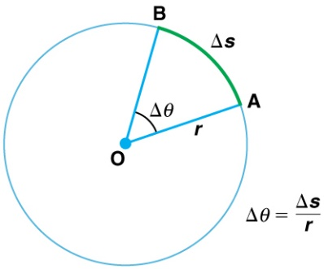

$$∆θ=\frac{2πr}{r}=2π for one revolution$$

Now that we have a measure of angular displacement, we can define the term angular velocity, as the rate of change of the angle:

$$ω=\frac{∆θ}{∆t}$$

Our gyroscope sensors on our phones will measure the angular velocity around the x-, y-, and z-axes. Once you have the angular velocity, you will be able to calculate the angular displacement and subsequently determine the angular position as a function of time.

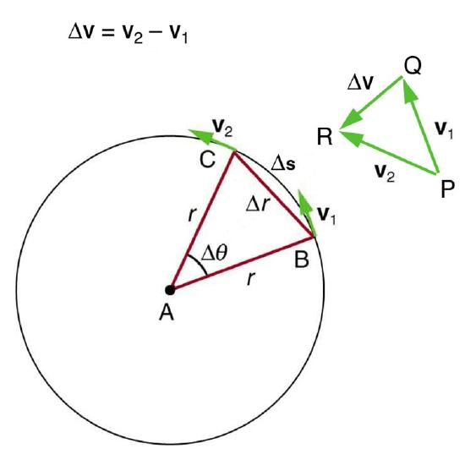For an object moving in a circle, the linear velocity at any point on the circle is tangential to it. When the object moves through an arc of angular displacement $Δθ,$ the direction of the linear velocity vector changes, as seen in the diagram at the right. Since acceleration is the rate of change of velocity, a changing velocity direction means there is an acceleration. In the diagram, tip-to-tail vector addition, ${\vec{v}}_{2}={\vec{v}}_{1}+∆\vec{v}$ shows that $∆\vec{v}$, and therefore the acceleration, is pointed inward, toward the center of the circle. Thus, this acceleration is known as “centripetal” or “center-seeking” acceleration. The magnitude of the centripetal acceleration is related to the angular velocity by the relationship:

$$a_{c}=rω^{2}$$

In this activity you will have the opportunity to explore the centripetal acceleration and the relationship to the angular velocity by making measurements using the gyroscope and the accelerometer simultaneously.

**Pre-Lab Activity (20 minutes)**

1. You will be making measurements of the angular velocity using a gyroscope. The units of the angular velocity are radians/second (or rad/s). Most of us are more familiar with the use of degrees to denote angular measurements. To help build a connection between radians and degrees, calculate how many degrees your body would move in one second if you were spinning at an angular velocity of 1 rad/s? Show your calculation below.
2. 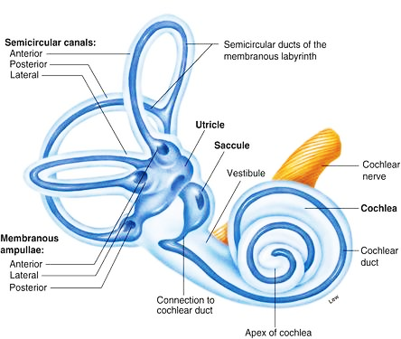The vestibular system is a sensory system in the inner ear that helps one maintain a sense of balance, motion, and body position. The operational principle of the vestibular system has remarkable parallels to the MEMS 3-axis gyroscope and accelerometer in our phones. Watch the two videos below. The videos will provide a foundation of knowledge for our investigation of rotational motion as well as illustrate how physics principles are central to our biological functions.
   * [Vestibular System Animation](https://www.youtube.com/watch?v=ryGMI3SpxCE)
   * [Khan Academy Lesson on Vestibular System](https://www.khanacademy.org/test-prep/mcat/processing-the-environment/sensory-perception/v/the-vestibular-system-balance-and-dizziness)

Based on the videos, answer the following questions:

* 1. **What are the primary structures in the ear responsible for detecting rotational motion, and how do they function**
     1. Cochlea; by detecting sound vibrations
     2. Semicircular canals; by detecting changes in fluid movement
     3. Utricle; by sensing vertical movement and gravity
     4. Tympanic membrane; by converting sound waves into mechanical motion
  2. **How do the semicircular canals contribute to the sensation of dizziness?**
     1. By detecting linear acceleration
     2. By measuring changes in temperature
     3. By sensing angular motion and sending incorrect signals to the brain when overstimulated
     4. By responding to gravitational forces
  3. **What role do hair cells in the vestibular system play in maintaining balance?**
     1. They protect the ear canal by collecting small airborne particles
     2. They detect fluid movement and send nerve signals to the brain regarding head movement
     3. They amplify sound waves
     4. They transport nutrients to the inner ear

**Experiment**

**Activity 1 – Characterizing the Gyroscope (60 minutes)**

You were introduced to the microscale design of a MEMS gyroscope in a previous [video](https://www.youtube.com/watch?v=9X4frIQo7x0). In this activity you will be using the gyroscope to measure angular velocity and begin to appreciate the wide range of applications gyroscopes can enable.

1. *Using the Gyroscope:* Quick introduction into making angular velocity measurements.
   1. While holding your phone in your hand, collect data with the gyroscope while you conduct 5 jumping jacks. Describe your observations in a few sentences. The description does not need to be comprehensive; we will begin to break down the details of the data as we continue with this experiment.

This simple measurement illustrates that the gyroscope can capture very complex patterns resulting from movement in three dimensions. Our investigation will help us understand the potential of using gyroscope measurements for characterizing the details of human motion.

1. *Sense of Rotation:* Design a simple method to introduce rotational motion around each of the phone’s three axes (while minimizing rotation around the other two). Experiment with rotation in the clockwise and counterclockwise sense.
   1. Indicate the sign of the angular velocity for CW and CCW rotation.

CW –

CCW –

* 1. Demonstrate your knowledge of the gyroscope by reproducing the response shown in the figure below for a series of movements around the three different axes. The exact amplitudes are not critical. Your graph should show the right order (i.e., x then z, then y), as well as the pattern that shows an initial negative angular velocity followed by a positive angular velocity for each axis.

1. *Quantitative Measurement of Angular Velocity*: In this activity you will work in pairs. Together, you will conduct an experiment to compare the value of the angular velocity measured by the gyroscope to the angular velocity you determine using visual observation (e.g., you use a stopwatch to time a number of full rotations made by your partner).
   1. Decide on a method to rotate your phone at a relatively constant angular velocity. For example: 1) hold your phone with extended arm in a fixed orientation and spin, 2) secure your phone on a rotating desk chair, or 3) choose your own method. Your phone should stay in a fixed orientation in the plane of rotation, and you should wait to start your observational measurement until a relatively constant angular velocity has been achieved.
   2. Collect data simultaneously using the two methods below:
   3. The average angular velocity determined by measuring the time for a fixed number of observed rotations
   4. The average angular velocity determined from the graph of the gyroscope sensor in phyphox using the pick data function
2. Complete the table below for two different trials.

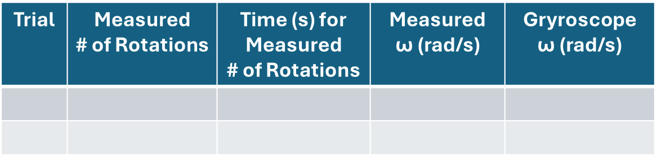

1. Compare the angular velocities measured using the two methods. Include your assessment of the accuracy of the two methods.

**Activity 2 – Calculating Angular Displacement from Angular Velocity (60 minutes)**

The previous activity gave you a qualitative sense that the accuracy of the gyroscope sensor was consistent with your visual observations. This activity will provide a much more quantitative assessment.

In this activity you will measure the angular velocity for a well-defined angular displacement. In a similar way as you used numerical integration of velocity to calculate displacement when investigating linear motion, you will use numerical integration of angular velocity to calculate angular displacement. This quantitative analysis will allow an assessment of the accuracy of the angular velocity measured by the MEMS gyroscope and help you better understand the potential applications that are possible using this sensor.

1. *Measuring Angular Velocity for a Precise Angular Displacement:* Design an experiment where you can measure the angular velocity of your phone as it undergoes a well-defined rotation (e.g., *π*/2, *π, or 2π*). Geometries might include:
   * Carefully rotating it on a table with your hands
   * Holding it level and rotating your body
   * Using a rotatable platform (chair, Lazy Susan, fidget spinner…)
2. Be sure to precisely measure and record the total angular displacement for your observed rotation for comparison to your calculated value.
3. Export your data for analysis.
4. Capture a screenshot of the “graph” mode showing all three axes and insert the screenshot below.

1. *Analyze the Angular Velocity Data:* Calculate the angular displacement from your angular velocity data using numerical integration and graph both angular velocity and angular displacement vs. time on the same graph. Recall from the introduction:

$$ω=\frac{∆θ}{∆t} → ∆θ=ω∆t$$

Include your graph below.

* + 1. Compare your measured value of the angular displacement to the value calculated from the angular velocity data by calculating the percent difference. Discuss the quality of the agreement.

$$\% difference=\frac{|Measurement 1-Measurement 2|}{Average}x 100$$

**Activity 3 – Characterizing Centripetal Acceleration (50 minutes)**

In this activity you will use the accelerometer to measure the centripetal acceleration experienced by an object during circular motion. You will also explore the relationship between centripetal acceleration and angular velocity.

1. *Measuring the Direction of Centripetal Acceleration:* Hold your phone in your hand with arm extended. Spin at a constant rate for several seconds. Use “acceleration (without g)” to measure the acceleration experienced by the phone.
   1. Make a measurement while holding the phone with the negative y-axis directed toward you. Insert an example screenshot and discuss if your observation is consistent with your expectations.
   2. What experiments could you conduct to confirm that the acceleration of your phone is always directed toward the center of rotation? Conduct the experiments and explain how your findings support the claim that the centripetal acceleration is always directed toward the center of rotation.
   3. We saw that the sign of angular velocity changes depending on the direction of rotation. Does the sign of the centripetal acceleration depend on the direction of rotation? Conduct a quick test to confirm your answer.
2. *Using the Relationship between Centripetal Acceleration and Angular Velocity*: In this experiment you will use average values of the centripetal acceleration and the angular velocity to estimate the radius of rotation for a system undergoing uniform circular motion. Recall from the introduction:

* 1. Create a “simple experiment” within the phyphox application (tap the plus sign on the main menu) to create a custom experiment where you collect both linear acceleration and gyroscope data.
  2. Collect data using this custom experiment while you spin with your arm extended at a constant rate for ~5 s.
  3. Using a meter stick, measure the distance from the phone to your center of rotation.   
       
      Distance =
  4. Using your measured values of the centripetal acceleration and the angular velocity, calculate the radius of rotation.  
       
      Centripetal Acceleration:

Angular Velocity:

Calculated Radius:

* 1. Compare your values for the radius of rotation (from c. and d.) by computing the % difference as:

$\% difference=\frac{|Measurement 1-Measurement 2|}{Average} x 100$

Discuss the quality of agreement.

1. A picture containing text, electronics, camera, projector

   Description automatically generated*Relationship between Centripetal Acceleration and Angular Velocity:* Use the geometry shown below to create a rotational table for your phone using a fidget spinner.
   1. Use the “Centripetal acceleration” tool in phyphox along with a “timed run” to collect data over a range of angular velocities. You can do this by starting your phone spinning and collecting data for 20-60 seconds while it slows down.

* 1. Export your data and create graphs of: 1) centripetal acceleration (y-axis) vs angular velocity (x-axis), and 2) centripetal acceleration (y-axis) vs the square of the angular velocity (x-axis). Use the Chart Design menu to “Add a Chart Element” 🡪 “Trendline” for each graph. What functional shape gives the best fit in each case? Include the equation for the trendlines on the graphs. Insert your graphs below.
  2. Was your finding consistent with the relationship presented in the introduction?
  3. The slope of your graph for centripetal acceleration vs the square of the angular velocity will be the radius of rotation. How far was the sensor located from the center of rotation?