**Exploring Momentum and Impulse**

**Objectives**

Upon completion of this lab, students should be able to:

* Describe how forces and momentum change during an interaction / collision
* Design experimental tests that could be used to characterize the impulse during a collision using an accelerometer
* Graphically illustrate force, momentum, and impulse during a collisional process
* Propose and evaluate engineering designs that could be used to minimize the force experienced during an interaction / collision

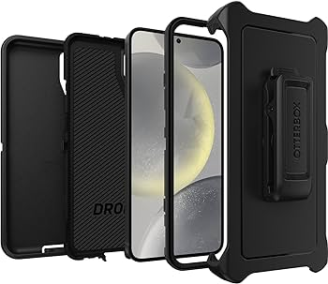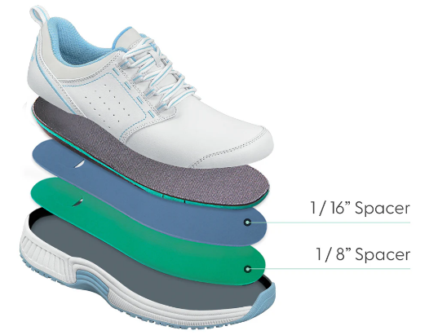

Examples of mechanical and biological designs to reduce the force during a collision are illustrated for: 1) a phone case, 2) an athletic shoe, 3) a human skull and meninges protecting the brain. Each of the systems use a combination of structural design and material properties to extend the time over which there is a change in momentum.

**Introduction**

**Introduction**

In this activity, you will continue your investigation on how forces alter the motion of objects. You will draw on your daily experience where you inherently feel less concerned when you drop your phone on a carpeted floor compared to dropping it on the concrete. Our investigation will build the scientific understanding of why these two cases present such different risks to damaging the phone. This principle involving the time scale for the change in momentum is behind the design of many engineered technologies as well as the evolutionary details of biological systems that optimize the protection of vital organs and enable mobility necessary for survival.

As a framework for our understanding, we will introduce the mathematical basis that will allow us to more effectively develop models for the interaction of objects and the resulting changes in motion. We start with Newton’s second law and write the acceleration in terms of the change in velocity divided by the time needed to make that change.

$$\sum{F}=F_{net}=ma=m\left(\frac{∆v}{∆t}\right)$$

Multiplying both sides by *Δt*, results in the following expression:

$$F_{net}∆t=m∆v$$

where the product of the average net force on an object over the time interval over which it acts, $F_{net}Δt,$ is the **impulse**. The impulse is measured in units of Newton-seconds.

The right side of this equation represents the product of the mass and the change in velocity (velocity final –velocity initial) and can be written as:

$$m∆v=mv_{f}-mv_{i}$$

where the product of the mass and the velocity is the **momentum**, $p = mv$**.** Putting this together leads to the **Impulse-Momentum Theorem**:

$$F_{net}∆t=p_{f}-p_{i}$$

This relationship is foundational for the understanding of collisional processes where forces are acting on objects.

We can use this relationship to explain what happens in the two scenarios of dropping our phone described above. When the phone collides with the floor it goes from a few meters per second velocity, with an associated momentum just before hitting the floor, to zero velocity and zero momentum moments after the collision. The impulse-momentum theorem can help us understand the process that takes place during the collision. We can see that for a fixed change in momentum, the difference between the two scenarios is the time over which it will take to go from maximum momentum to zero momentum. When the time is short, like in the collision with concrete, the force experienced by the phone will be large. If the time of the collision is extended, like in the case with compressible carpet, the force will be less. Reducing the force experienced by our phones is a good thing and will prevent us from seeing the dreaded shattered display glass. Phone cases are designed with these principles in mind and when designed well, do a very good job at protecting our phones.

**Pre-Lab Activity (45 minutes)**

1. A picture containing mountain, sky, outdoor, nature

   Description automatically generatedA picture containing accessory, flag, underpants

   Description automatically generatedWatch [this video](https://youtu.be/GaANi96Z-Wg) of Luke Aiken who jumped out of an airplane at 7,600 m without a parachute and landed in a net on the ground. Next watch [this video](https://www.youtube.com/watch?v=UtrpLIDHFGU) where he describes how he did it. (This video is a little long but we hope you find it entertaining as well as educational.) Describe how Luke was able to survive this large-scale physics experiment using the terms force, impulse, and velocity.
2. 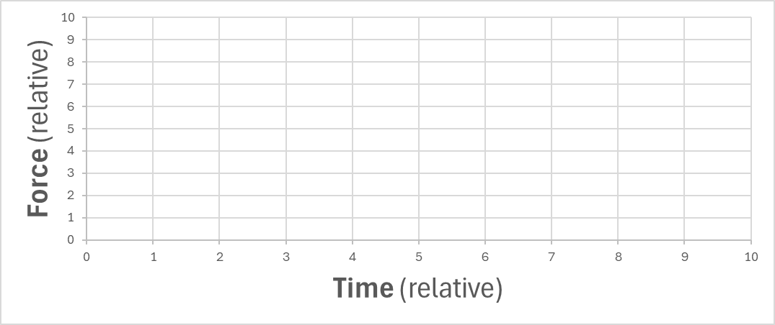Consider two scenarios of a beach ball bouncing off a flat surface. In one case, the beachball is highly inflated and in the other case the ball is slightly underinflated. The initial velocity, and hence the initial momentum, for the two scenarios is the same. Create a qualitative graph of force on the ball from the surface vs time for each of the balls on the graph below. Your goal is to illustrate the relative differences of the collision processes between the two scenarios. (Hint: In which case will the interaction time be longer? How will that change the peak force experienced during the collision?)

**Experimental Guide**

In this experiment you will introduce an impulse by applying a constant force to your phone for a short period of time. You have learned how to do this from your experiment with kinetic friction. You have already measured how kinetic friction results in a constant force when two objects are moving in opposite directions while their surfaces are in contact. In today’s investigation, you will use a different experimental design to introduce an impulse. You will characterize the force as a function of time using the accelerometer, hence providing a measurement of the impulse. In fact, this experiment will involve two impulses on the phone that result in a net zero change in momentum. You will finally calculate the velocity of the phone during the experiment allowing you to measure the change in momentum of the phone throughout the experiment.

**Activity 1 – Measuring an Impulse with an Accelerometer (120 minutes)**

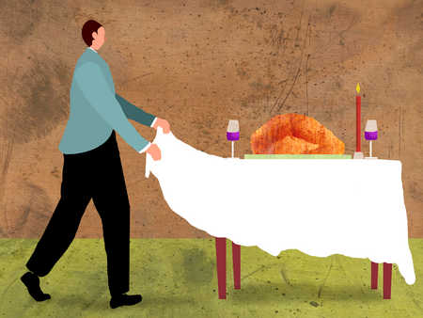When a “magician” pulls a tablecloth out from under a dish, the tablecloth and the bottom of the dish slide by each other and hence undergo a “collision” for a short period of time. From your experience, you know this particular type of collision involves kinetic friction as two surfaces move across each other.

1. *Describe the Physics of the “Trick”:* Using terms such as kinetic friction, inertia, and impulse, discuss with a partner why the magic trick is not magic and can be explained by the laws of physics you have learned. Write a summary of your discussion below.
2. *Controlling the magnitude of the impulse:* Let’s take a moment to think more deeply about how the impulse can change during an experiment designed using the same principles as the “magic trick”. We will use a piece of paper as the tablecloth and our phones secured on a paper plate for the dish. Consider the following questions.
   1. For a given piece of paper and plate, the coefficient of kinetic friction is fixed. Does the speed at which you pull the paper change the magnitude of the force exerted on the plate? (Hint – The coefficient of friction is independent of the velocity and **Fk**=µkm**g**.)
   2. Does the speed at which you pull the paper change the magnitude of the impulse? Explain.
   3. What happens if you pull the paper too slowly? Describe in terms of impulse and the resulting displacement of the plate.
   4. What happens if you pull the paper “infinitely” fast? Describe in terms of impulse and the resulting displacement of the plate.
   5. We want to be able to measure the impulse using the accelerometer in our phones that in many cases has a 100 Hz sampling rate. What can we say about the speed at which we should pull the paper in our experimental design?
3. *Design and Conduct the “Impulse” Experiment:* Conduct an experiment that is similar to the classical magic trick above. Replace the tablecloth and place setting, with a piece of paper and your phone as shown below (or with your phone secured to a paper plate). If you are concerned about your phone in this experiment, use one of the loaner phones that your instructor can provide. Consider padding the area where your phone might drop if it moves too far.

* 1. Find a flat uniform surface to conduct the experiment.
  2. Make sure your phone or phone case has a smooth uniform surface in contact with the paper. If the back of your phone does not provide uniform contact (e.g., camera lens sticks out), secure your phone to a paper plate to provide a more uniform surface. This will also provide additional protection to your phone if it is secured to a paper plate, so it is recommended as the default approach if you do not have a protective case.
  3. Place a piece of paper on the flat surface and place your phone on the paper. Consider different geometries and think about how they might impact your experimental observations.
  4. Start collecting acceleration data using “acceleration with g” in phyphox. You may find that a timed run will be useful to simplify data visualization.
  5. Quickly, pull the paper out from under the phone. Pull straight so you do not provide any upward force to the phone. Your goal is to provide a rapid frictional force on the phone.
  6. You should explore different geometries which will vary the time in which the phone will be in contact with the paper. For example, placing the phone in the center of the paper to start the experiment rather than close to the edge, will change the Δt for a constant velocity and will increase the impulse.
  7. The impulse can also be changed by changing the velocity at which you pull the paper. Explore the combination of velocity of your pull and the positioning of the phone to optimize your measurement.
  8. Once you find a satisfactory design, collect your data and export for analysis. (It is recommended you show your data to your instructor before moving to the next step.)

1. *Analyzing Acceleration vs Time:*
   1. Create a graph of the acceleration vs time.
   2. Include the graph below and indicate the times where the following physical processes are taking place on the graph.
      1. Phone on the paper at rest on the flat surface
      2. Phone accelerating due to the frictional force between the paper and the phone
      3. Phone accelerating due to the frictional force between the flat surface and the phone
      4. Phone at rest on the table
2. *Analyzing Impulse*:
   1. Create a graph of force vs time. This will require you to know the mass of your phone. Include the graph below.
   2. Using your graph, estimate the impulse on the phone that results from the frictional force with the paper. Show your calculation.

Impulse =

* 1. Using your graph, estimate the impulse of the phone that results from the frictional force of the stationary flat surface and the sliding phone. Show your calculation.

Impulse =

* 1. Compare the two impulses and discuss the relationship between the two values.

1. *Characterize the Change in Momentum*:
   1. In your spreadsheet, calculate the velocity of the phone for every data point in your experiment using numerical integration. Remember to calculate the y-offset correction for your acceleration data and concentrate on data for about ~1-2 s near the region of interest.
   2. Using the phones mass and the velocity, create a new column containing the momentum of the phone.
   3. Create a graph showing both the force vs time and the momentum vs time on the same graph. (A secondary axis for the momentum will give the best visualization. If that is not possible, align the two graphs vertically and be sure that they have the same x-axis boundaries.)
   4. *Connecting Momentum and Force Graphically*: Examine the shapes of the force vs. time graph and the momentum vs. time graph. How does the slope of the momentum vs. time graph at a given point relate to the force at the same point in time? Explain using the impulse-momentum theorem.

**Activity 2 – Sports Turf Performance and Protection (40 minutes)**

Years of research and testing have gone into the design of artificial turf for athletics. There are many different requirements, but a key requirement is to provide safety and reduce injuries for the athletes competing on the surfaces. The Advanced Artificial Athlete (shown in the image below) is an instrument designed to test turf for performance and safety. A detailed description of this test is available in the [*FIFA Quality Programme for Football Turf*](https://digitalhub.fifa.com/m/7cfc3106515eb3e2/original/FIFA-Quality-Programme-for-Football-Turf-Test-Manual-I-Test-Methods-April-2024-edition.pdf) if you are interested in additional details. Similar to the experiment you just conducted, this approach uses an accelerometer to determine the peak force that occurs during the impulse. Watch this 2-minute overview [video](https://www.youtube.com/watch?v=7l-FEV_EMtU) of the instrument in operation.

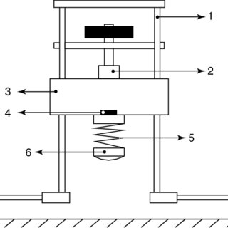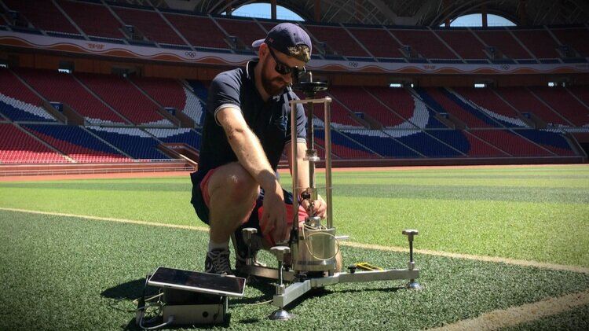

1. *Develop Your Own Test:* One of the concerns raised about this test instrument is that it does not mimic biomechanical movement of an athlete. How might you use your phone to conduct a measurement to assess the reduction of the force provided by different surfaces. Discuss potential methods in small groups. Include a short description of one approach and include a screenshot of some sample data below.
   1. Test your method to see if you can measure the differences between a very hard surface like concrete or a tile floor and a soft surface like turf or a carpet. Quickly discuss your findings below.

* 1. Could you develop an “app” that could be used for testing any playing surfaces (fields, tracks, tennis courts, basketball courts, …)?
  2. Do you think you could evaluate athletic shoe performance and the ability to protect athletes from injury?