**The Science of Collisions and Energy Transformation**

**Objectives**

Upon completion of this lab, students should be able to:

* A picture containing nature, crater, outdoor, people

  Description automatically generatedDiscuss the conservation of mechanical energy and the conversion between kinetic and potential energy for an object in free fall.
* Apply the equations of motion for constant acceleration to calculate the position and velocity of an object in free fall.
* Use a model of a ball colliding with a surface to describe the nature of elastic and inelastic collisional processes.

The Moon’s surface provides a historical record of collisions by meteors and asteroids. The lack of water, atmosphere and tectonic movement allows the craters to avoid erosion, and some craters are estimated to be over 2 billion years old.

* Evaluate how collisions between objects with different material properties can dramatically affect the transfer of energy during a collision and how to characterize the collisions using the coefficient of restitution.

**Introduction**

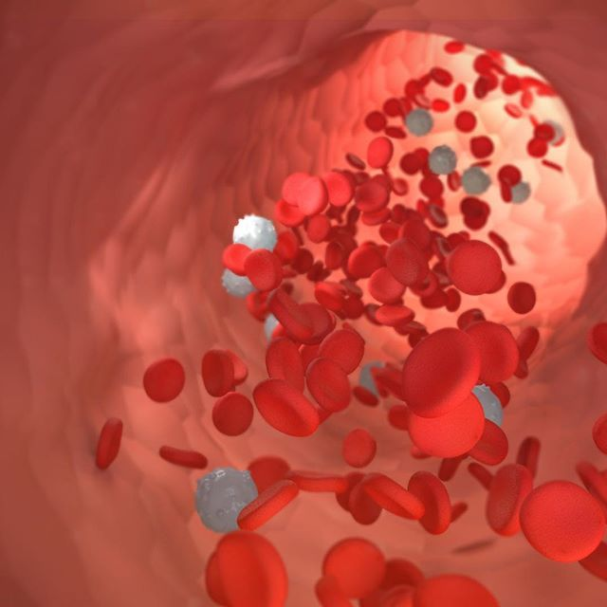Our investigations have been building an understanding of how forces can alter the motion of macroscopic objects, and we have learned how to characterize motion in multiple dimensions. You have learned to characterize the motion of the objects by measuring either acceleration (accelerometer), angular velocity (gyroscope), or position (GPS) and then calculating the values of other related variables. In the last experiment we measured impulses between pairs of interacting objects. The interaction of matter at both the macroscopic and microscopic levels is essential to our understanding of life and the design of technology that improves the lives of everyone.

The movement of blood cells through the cardiovascular system involves frequent collisions. These interactions are critical for understanding blood viscosity, how blood pressure affects circulation, and how different types of flow affect health.

In this investigation, we will continue to explore the interactions between objects but will also expand our examination by looking at the interactions through the lens of energy. Specifically, we will explore the **conservation of** **mechanical energy** of a free-falling object as well as characterizing how macroscopic kinetic energy is transformed during a collision to the motion and reconfiguration of atoms at the microscopic level.

The term collision represents an event during which two objects come close to each other and the interaction forces between them is much greater than any other external forces present at that moment in time. In an **elastic collision**, the total kinetic energy of the object remains the same before and after the collision. The collision between two atoms in an ideal gas is an example of an elastic collision. In an **inelastic collision**, the kinetic energy is not the same before and after the collision. Almost all collisions are inelastic, but can vary significantly in how much energy is lost.

In this investigation we will study collisions and the transformation of energy by investigating a model system of a bouncing ball. When the ball is released from a position above a surface, it will undergo a repeated sequence of collisions with the surface. We will measure the loss in mechanical energy for each collision and characterize the collision using the coefficient of restitution, which is defined as:

$$Coefficient of Restitution (e)= \frac{\left|velocity of separation after collision\right|}{\left|velocity of approach before collision\right|}=\sqrt{\frac{\left|Final kinetic energy\right|}{\left|Initial kinetic energy\right|}}$$

A value of the coefficient of restitution of 1, would represent a perfectly elastic collision. A completely inelastic collision would result in a coefficient of restitution of 0.

While there are several approaches we could use to investigate the collision of the ball with the surface, in this activity we will take advantage of the microphones in our smartphones to measure sound waves produced during the collision process, which allows the precise timing of each collision. We can then draw on our knowledge of the mechanics of free-falling objects that are experiencing the constant acceleration of gravity to calculate the height and the velocity of the ball at any time of interest. For reference, we include the equations of motion for constant acceleration:

$$y_{f}=y_{i}+v_{i}t+\frac{1}{2}gt^{2}$$

$$v_{f}=v_{i}+gt$$

where *yf* and *yi* are the final and initial positions, *vf* and *vi* are the final and initial velocities, *g* is the acceleration due to gravity, and *t* is the time.

As a reminder, the relationships for gravitational potential energy and kinetic energy are:

$Gravitational Potential Energy \left(GPE\right)=mgh$

$$Kinetic Energy \left(KE\right)=\frac{1}{2}mv^{2}$$

where *m* is the mass of the object, and *h* is the height above the reference point of zero potential energy.

**Pre-Lab Activity (30 minutes)**

1. If you drop a ball, describe how the energy of the ball is changing in terms of gravitational potential energy and kinetic energy?
2. Consider the movement of a ball between bounces (i.e., the time between two sequential collisions with the surface). Use a reference frame where the acceleration due to gravity is negative and the height of the surface is zero. Examine the graphs below and select the graph that best illustrates the functional form for a-f below:

* 1. Position vs time of the ball. Graph ___
  2. Velocity vs time of the ball. Graph ___
  3. Acceleration vs time of the ball. Graph ___
  4. Gravitational potential energy vs time of the ball. Graph ___
  5. Kinetic energy vs time of the ball. Graph ___
  6. Total mechanical energy vs time of the ball. Graph ___

1. Do you expect the ball to bounce back to the original height from which you dropped it? If the ball has less mechanical energy after each bounce/collision, where did the energy go? Provide possible explanations.
2. 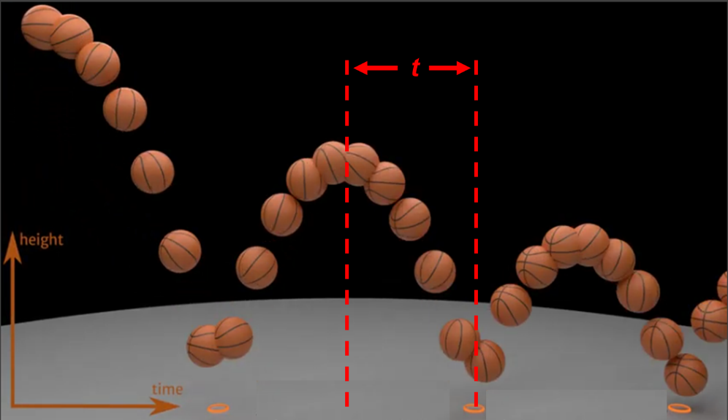Using the equations of motion provided in the introduction, derive the following equations based on the model of the bouncing ball, where the time, *t*, is the time between the two red dotted lines as shown. You will be using these equations in your analysis.
$$Height of the bounce=∆h=\frac{1}{2}gt^{2}$$

$$velocity of approach before collision=gt$$

3. How can we determine the illustrated time by measuring the time between two bounces? Explain your answer.

**Experimental Guide**

In this experiment you will characterize the collision between a ball and a surface for a few different scenarios. By carefully measuring the time between collisions you will be able to use the equations you have developed to determine the height of each bounce as well as the maximum velocity of the ball between bounces. With this information you will be able to determine both the mechanical energy of the ball after each bounce and calculate the energy lost (and the energy retained) during each collision. You will also be able to determine the coefficient of restitution, which provides a simple way to characterize the collision as more elastic or more inelastic.

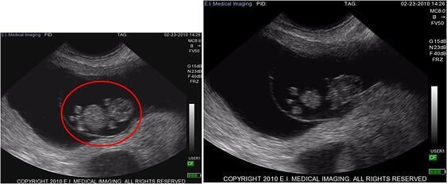

This activity also introduces you to using the microphone on your phone to precisely measure sound waves with extraordinary precision. The ability to produce and measure sound waves with high levels of precision has widespread applications in medicine, human health, and the communication of most living creatures.

Bovine Ultrasound at 40 Days

**Activity 1 – Precision Characterization of Collisions (90 minutes)**

In this activity you will use phyphox (audioscope) to measure the soundwaves associated with a bouncing golf ball on your lab benches.

1. *Measure the Data Collection Rate of the Microphone:* Collect 10 ms of data using the audioscope. Determine the data collection rate of the microphone by using either: 1) Pan and zoom and pick data, or 2) Exporting the file and determining the time between points from the time data. (Note the time is in milliseconds.) Show your calculation and report your data collection rate.

*Data Collection Rate (Hz) =*

1. *Capture a Sequence of Bounces on Audio Scope*: You will want to set the data collection time to the maximum value which is 500 ms.
   1. Drop your golf ball from a short distance (~5-15 cm) above the surface of the lab bench and observe the pattern detected by the Audio Scope. You may not be able to capture all of the collision events from a single drop. After making several observations, adjust the height of your drop so you can capture 5-7 collision events during the 500 ms observation time. Pausing data collection to capture the data you want will take some practice (and a little luck / patience). Export your data to Excel for analysis.

* 1. Create a graph of amplitude vs time. Insert your graph below.
  2. Using your graph, determine the precise time of each collision by expanding the time axis around each “collision” on your graph and determining the time when the first detectable disturbance from the soundwave arrives at the microphone. This process is a little time consuming but assures you get the most accurate measurement of the arrival time of the sound wave.

1. *Analysis of Your Data:* Using the formulas presented in the introduction and derived in the prelab, create a spreadsheet with the columns shown below and conduct the analysis.

* 1. Before conducting the analysis, use the figure below to indicate the time that should be used in your equations to calculate the maximum height and the maximum velocity. (see question 5 in the prelab)

* 1. Insert a screenshot of your completed spreadsheet below.
  2. Determine the average values for the % retained energy and the coefficient of restitution (you can do this in your spreadsheet if you desire).

Average % retained energy =

Average coefficient of restitution =

1. Based on the individual values for the % energy retained and the coefficient of restitution, make a hypothesis on how the energy retained depends on the velocity of the ball prior to the collision.
2. What would you expect to observe if the energy retained was dependent on the velocity of the collision?
3. The energy for a bouncing ball is shown in the graph below. Describe what is happening to the gravitational potential energy, kinetic energy and total mechanical energy during the times specified in the questions below.

1. The time just prior to a collision compared to the time just after the collision.
2. During the time immediately after the ball leaves the surface following a collision until the time just before it collides with the surface again. Explain in terms of conservation of energy.

**Activity 2 – Comparison of Different Collision Pairs (60 minutes)**

The differences in how different types of balls bounce is very important in sports. We expect tennis balls, golf balls, baseballs, and basketballs to all behave differently when they collide with different surfaces such as rackets, clubs, bats, or gym floors.

[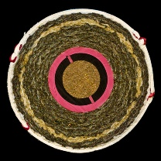](http://www.technocrazed.com/wp-content/uploads/2015/08/Discover-Amazing-Cross-section-View-Of-22-Everyday-Objects-Cut-In-Half-16.jpg) [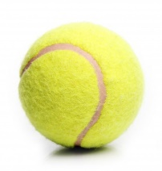](https://www.google.com/url?sa=i&url=https%3A%2F%2Fwww.freepik.com%2Ffree-photos-vectors%2Ftennis-ball&psig=AOvVaw19EMHKDbX7_HyIIDpt6odv&ust=1602861900060000&source=images&cd=vfe&ved=0CAIQjRxqFwoTCICqgID0tuwCFQAAAAAdAAAAABAe) [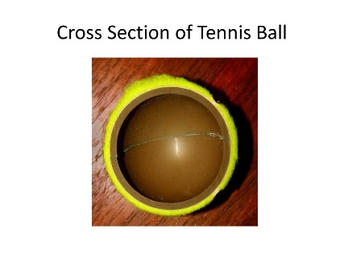](https://www.google.com/url?sa=i&url=https%3A%2F%2Fwww.slideserve.com%2Fnell-savage%2Fs-o-s&psig=AOvVaw1v3OzacHtZhMoUicOVYORf&ust=1602861694804000&source=images&cd=vfe&ved=0CAIQjRxqFwoTCJip3KnztuwCFQAAAAAdAAAAABAJ) [](https://www.google.com/url?sa=i&url=https%3A%2F%2Fwww.businessinsider.com%2Fbest-golf-ball&psig=AOvVaw3gBzN4BkH_5S8hYcA80BDW&ust=1602862129391000&source=images&cd=vfe&ved=0CAIQjRxqFwoTCLi63O30tuwCFQAAAAAdAAAAABAF)[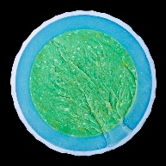](https://www.google.com/url?sa=i&url=https%3A%2F%2Fwww.robotspacebrain.com%2Fgolf-ball-cross-sections%2F&psig=AOvVaw3oQ5UMcmrK4Vr6J8tCm3IJ&ust=1602862287603000&source=images&cd=vfe&ved=0CAIQjRxqFwoTCIDPkLn1tuwCFQAAAAAdAAAAABAH)

1. What properties do you think might be important in making collisions more elastic or inelastic?
2. What makes a collision elastic or inelastic is not always intuitive from our everyday observations. Consider a steel ball bouncing on a heavy steel plate. Estimate how you might expect the collision to behave on the scale below and then watch this [video](https://www.youtube.com/shorts/hlW9zdNNc88?app=desktop) of the experiment. Discuss the observation and provide a possible explanation.

Very Elastic ----------------------------------------------------------------------------------Very Inelastic

1. Explore the use of the **Acoustic Stopwatch** module in the phyphox application. This application starts and stops a timer when it measures an increase or decrease in the pressure associated with a sound wave.
   1. Investigate the use of the **Simple**, **Sequence** and **Parallel** modes of operation. Observe how changing the **Threshold** and **Minimum Delay** setting is used to control the starting/stopping of the timer based on the amplitude of the sound wave. The delay is used to make sure that a single “sound” that persists for many milliseconds does not start and stop the timer. Describe how you could use the “Acoustic Stopwatch” to measure the time of sequential bounces of a ball as you did in Activity 1.
   2. Use the Acoustic Stopwatch to repeat the analysis you did in Activity 1. Use the same golf ball and surface. Make a copy of the spreadsheet you created to determine the percent energy retained and the coefficient of restitution. Replace the times with those measured by the acoustic stopwatch. Insert an image of the spreadsheet analysis below.
   3. How did the two methods compare?
2. The “(In)elastic Collision” module in phyphox is designed as a tool to carry out the analysis you have been doing in your spreadsheet. Using this automated tool, measure the average percent energy retained for 4 different ball/surface combinations including the one you have been investigating. You may need to adjust the **Threshold** and **Minimum Delay** in **Settings** to achieve reproducible results (i.e., each individual collision should provide similar values for % energy retained). Provide screen shots of your data and summarize your data in a table. (example shown)

|  |  |
| --- | --- |
| **Ball / Surface** | **Average % Energy Retained** |
|  |  |
|  |  |
|  |  |
|  |  |

1. Consider the various ball and surface combinations that you investigated. Discuss the variation in the percent energy retained for each of the different conditions that you investigated. What was similar? What was different? Do you observe any trends that you might use to predict how elastic or inelastic a collision might be?

* 1. If the energy was lost to “heat”, do you think more heat went into the ball or into the surface? Describe how you might design an experiment to answer that question.

1. The coefficient of restitution is often used in sports involving balls. The coefficient of restitution is important in developing regulations that maintain fairness and uniformity for the sport as it is played in different locations with different balls. If you ever played basketball, you know that different balls bounce differently on different surfaces. Below is a chart that shows the coefficient of restitution for a basketball bouncing on the home courts of NBA teams (measured using high speed video).

As you can see from the graph, some teams have a consistently higher or lower value of the coefficient of restitution. Coaches are known to manipulate this to benefit the playing style of their teams. Different basketball leagues have different ways of regulating the coefficient of restitution. These rules are summarized below. Utilize your knowledge of inelastic collisions and the processes that influence the coefficient of restitution to compare the relative effectiveness of the different rules. Discuss the merits and limitations of each method.

1. Often some of the simplest inventions require careful thought and a deep understanding of physics. Have you ever seen cabinet door bumpers that are designed to allow drawers to close smoothly and quietly? Using what you know about impulse and inelastic collisions, discuss the properties you would want to incorporate into the best bumpers.

