**Investigating Physiological Hand Tremor**

**Objectives**

Upon completion of this lab, students should be able to:

* A picture containing diagram

  Description automatically generatedUse accelerometer and gyroscope sensors to characterize the frequency and magnitude of tremors in living organisms.
* Use artificial intelligence tools to assist in conducting mathematical analysis of complex data sets.
* Design an experiment to evaluate and compare changes in physiological tremor that might occur due to changes in external variables.

**Introduction**

Over the past 8 weeks you have been learning how to use a wide range of MEMS sensors to characterize motion in multiple dimensions. You have used a 3-axis accelerometer to measure linear acceleration and a 3-axis gyroscope to measure angular velocities. You studied the precision and accuracy of these devices. You have learned how to extract detailed information from the sensor data to characterize displacement, velocity, and acceleration (linear and angular) for a range of different scenarios. Through these studies you have been able to assess the sensors’ capabilities and limitations. One observation you made was that the sensors could easily measure involuntary movement of your hands when you held your phone. You are now prepared to apply your understanding of these extraordinary sensors to biomedical applications. In this activity you will investigate and quantitatively characterize very minor tremors of your hand. The capability to measure minor tremors in humans and animals has the potential to enable incredible insight into their current physical state, medical health, and monitor the effectiveness of medical interventions. This is an active area of medical research.

Tremors are involuntary rhythmic muscle contractions that can cause body parts to shake or tremble. In humans, physiological tremor is a normal phenomenon present in all individuals to some extent. Physiological tremor typically has a frequency of 8-12 Hz and is often so small that a person does not see or notice the movement. External factors such as stress, fatigue, vigorous exercise, caffeine, and other bioactive molecules can enhance physiological tremor.

In addition to physiological tremor, tremors can be cause by neurological disorders such as:

* Parkinson’s disease
* Multiple sclerosis
* Stroke
* Traumatic brain injury
* Dystonia

Tremors are not exclusive to humans; animals also exhibit tremors due to various conditions:

* Canine Tremors: Dogs may experience tremors from conditions like idiopathic cerebellitis or distemper.
* Equine Tremors: Horses can develop tremors from neurological disorders such as shivers or equine protozoal myeloencephalitis.
* Feline Tremors: Cats may exhibit tremors due to toxin exposure or metabolic disorders.

Measuring physiological and neurological tremors with mobile sensor technology offers a unique opportunity to explore the intersection of physics, biology, and technology. The ability to conduct 24 hour a day monitoring of tremors in humans and animals can provide critical information for health. Your generation of scientists and engineers is in a position to combine advances in microelectronics and artificial intelligence to create incredible health benefits. What you are learning in this class is preparing you to play an active role in this amazing future.

**Pre-Lab Activity (30 minutes)**

As you pursue your career in human or veterinary medicine you will find it necessary to read journal publications on current research topics to advance your knowledge and expertise. Unlike most textbooks that you have used to support your traditional classes, research publications will contain many concepts and ideas that are outside your current knowledge – making them challenging to read and comprehend. Learning how to read such documents and extract “bits” of useful information surrounded by lots of words and topics you don’t understand, is a skill that will allow you to learn at an accelerated rate. In preparation for this week’s lab investigation, read the journal [article](https://pmc.ncbi.nlm.nih.gov/articles/PMC9386269/) titled “A standardized accelerometry method for characterizing tremor: Application and validation in an aging population with postural and action tremor”.

1. Read as much of the article as you can in 20 minutes. Discuss one idea from the paper that you found interesting about this medical research study.
2. Draft a question on some aspect of the information presented in the paper to ask your classmates. We will ask some of your questions in class to help us all share ideas and better understand the research paper.

**Experimental Guide**

In this experiment, you will use the accelerometer and the gyroscope in your phone to measure the motion that results from the physiological tremor in your hand. You will start with your own experimental design and evaluate potential ways to improve the clinical measurement. You will then repeat the measurement using a specific experimental design and quantitively characterize your hand tremor in terms of magnitude and frequency. The data analysis will utilize methods you have developed in previous labs as well as a new method which takes advantage of artificial intelligence tools to conduct automated frequency analysis. Finally, you will design and conduct your own experiment to explore external factors that may influence the tremor frequency and magnitude.

**Activity 1 – Preliminary Characterization of a Physiological Tremor (30 minutes)**

In this activity you will measure the physiological tremor in your hand by simultaneously measuring the acceleration and the angular velocity. You will use the standard deviation of the acceleration and the angular velocity for different axes as a metric of comparison.

1. *Decide on an Experimental Design with Your Group:* How you hold your phone, the position of your arm, the position of your body, and the time of your measurement are all potential factors that might contribute to the magnitude of your tremor. You will set up a “simple experiment” using phyphox that will allow you to collect data from the accelerometer (listed as linear acceleration in the phyphox set up menu for simple experiments) and the gyroscope simultaneously. This experiment will generate 6 independent sets of data. You will need to decide which axis or axes to use in the analysis. Using a timed run will allow you to isolate your data collection to the measurement of the tremors and eliminate other irrelevant movement (this simplifies visualization). Experimentally evaluate several different approaches and then decide on a final experimental design. Describe your final experimental design below. Include comments on observations that led you to decide on your final design.
2. *Collect Data:* Each person in the group should collect their own data using the same experimental design. Include a screenshot of your phyphox data below.
3. *Export the Data to a Spreadsheet for Analysis:* Use the standard deviation function (STDEV.P) to quantify the magnitude of the variation in the acceleration and the angular velocity produced by your physiological tremor (only use the data during the appropriate time that captures your tremor amplitude and no other movements). Include a table which includes the standard deviation data for you and your lab partners. An example table is shown below. You may decide to only evaluate some of the variables.

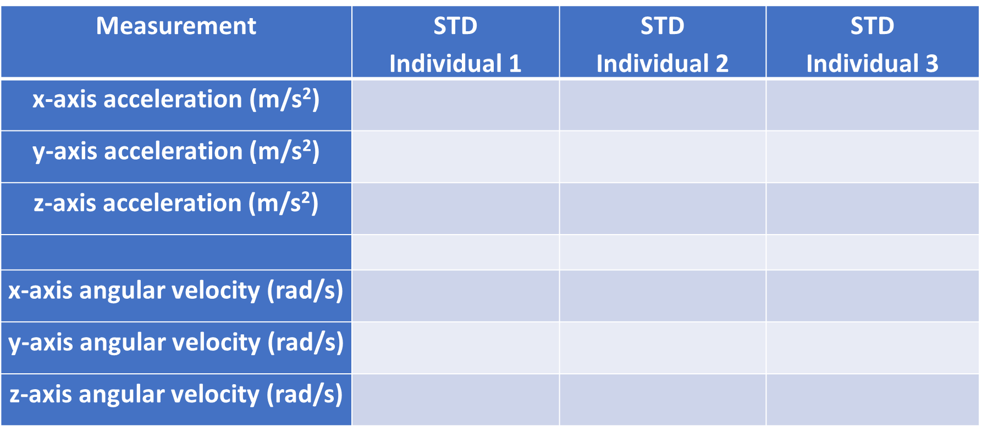

1. *Inspection of the Time Domain Variation:* Using either phyphox or Excel, create a graph of the acceleration vs time for one of your axes over a 2-3 second time period. Insert below. Describe any patterns or lack of patterns in the data that are visually observable.

**Activity 2 – Characterization of the Physiological Tremor Frequency of Your Hand (90 minutes)**

1. A person holding a cell phone

   Description automatically generated with medium confidenceIn this experiment we will use a specific experimental design intended to isolate the tremors of your hand from other biomechanical movements (e.g., elbow, shoulder, …). Rest your forearm on the arm of a chair or lab bench with only your wrist and hand suspended in the air. With your palm face down, place your phone on the back of your hand. While holding your hand, wrist, and body as steady as possible, use your simple experiment which collects “Linear Acceleration” and “Gyroscope” data, to measure the movement of your hand for 10 seconds using a timed run.
   * 1. Visually evaluate the data for the three different axes for each sensor. Describe your observations and discuss the differences you observe between different axes on the different sensors. Can you explain the differences in your observations from the biomechanics of the hand and wrist?
2. *Inspection of the Time Domain Variation:* Using phyphox, identify a section of the acceleration vs time data where a uniform oscillation pattern is well defined. Use the “pick data” function to measure the time for 3-5 oscillations. Insert a screenshot of the graph below. Calculate the frequency of your tremor and show your calculation.

*Frequency of tremor (Hz) =*

1. *Conversion of Time Domain Data to Frequency Domain:* Determination of the frequency using the manual approach above is slow and will be increasingly difficult when multiple oscillation frequencies are present. Determination of the frequencies in this more complex situation is possible using a mathematical approach often referred to as a Fast Fourier Transform, FFT. Instead of looking at the signal at each moment in time, the FFT does a transformation to the frequency domain by analyzing the signal over a longer period of time and determines the patterns of oscillation that are present. The result is a transformed data set containing amplitude vs frequency. The graph of amplitude vs frequency is often called a power spectrum – which you were introduced to in the paper you read in the prelab.
   1. Export your data from phyphox as a CSV file
   2. Use ChatGPT or your favorite AI tool to conduct this mathematical analysis. An example prompt for the chatbot is shown below:

**Prompt:** I am uploading a file containing amplitude vs time data I have measured using an accelerometer. There is data for all three axes. Convert the z-axis data to the frequency domain. Ignore the first data point at 0 Hz for the next actions. Provide a third column where the amplitude data has been smoothed using a 5-point moving average. Graph the power spectrum for both data sets from 0-25 Hz. Provide the value of the peak frequency. Provide a file containing the amplitude (power) vs frequency that I can export for graphing in a spreadsheet.

*Note:* You can choose to ask the chatbot to analyze other axes if you desire. You will see that the initial analysis is very noisy as it provides an amplitude for every 0.1 Hz. That is more resolution than what we need, so we can smooth the data to make it easier to visualize. An easy smoothing function is to use a 5-point moving average. You can try other smoothing functions if you desire. An artifact of the FFT analysis is that there is a spike at 0 frequency that is not real. The prompt instructs the chatbot to eliminate that data point, so it is not a visual distraction (or cause rescaling of the graph). Once you have asked the chatbot to do this, you can upload additional files and ask it to repeat the same analysis on new data sets.

Insert a screenshot of the graph produced by the chatbot below. Include the value of the peak frequency.

* 1. Using Excel, create a graph of the power vs frequency for the smoothed data returned by the AI tool. (You have seen examples of this in the paper you read in the prelab.). Insert the graph below.
  2. Now that you can conduct rapid analysis, make two more measurements using the same experimental design and analysis method. Create a table containing the peak tremor frequency from the three trials. This will be useful for our next experiment where we evaluate how external factors can change the tremor frequency. We need to know the variation of the measurement for identical conditions, before we can evaluate changes in the tremor frequency due to changing external variables.

|  |  |
| --- | --- |
| Trial | Peak Tremor Frequency |
|  |  |
|  |  |
|  |  |

**Activity 3 – Influence of External Factors on Physiological Tremor of Your Hand (50 minutes)**

1. You now have the tools to study how various external factors might impact tremor frequency. Several factors might include:

* Rigorous Exercise
* Caffeine
* Stress or Anxiety
* Supporting additional weight with your hand during measurement

Work with your group to decide on an experiment design to test the influence of one of these factors on tremor frequency. Conduct your experiment, draw conclusions, and provide data to support your conclusions. We will share our observations during the last 10 minutes of the lab.