**Characterizing the Human Gait**

**Objectives**

Upon completion of this lab, students should be able to:

* Design an experiment using MEMS accelerometer and gyroscope sensors to measure the patterns of motion associated with the human gait.
* Connect patterns in the measurement signals to specific elements of the gait cycle.
* Use numerical integration of the acceleration and angular velocity to characterize details of the human gait.
* Describe the connection between physical sensor measurements and the parameters that are provided in modern mobile health applications.

**Introduction**

Walking is the main mechanism that humans use for transporting themselves throughout their daily activities. Bipedal walking involves using two legs, alternatively providing suport and propulsion with at least one foot being in contact with the ground at any point in time. This sequence of events is often refered to as the gait cycle. Bipedal walking was a key component of hominid evolution and is a milestone in motor development during infancy. Walking is an emergent property of the central nervous system which requires an extremely well coordinated and finely modulated activation of muscles. This complex interaction manifests itself in the details of a human gait providing a unique signature. The fine features of human movement while walking can provide detailed insight into a person’s health. While the human gait is a repeatable motor phenomena that has similar characteristics for all humans, it is also a very individual trait that can be used for personal identification, and is affected by changes in age, injury, emotional state, physical condition, mental fatique, and environmental factors.

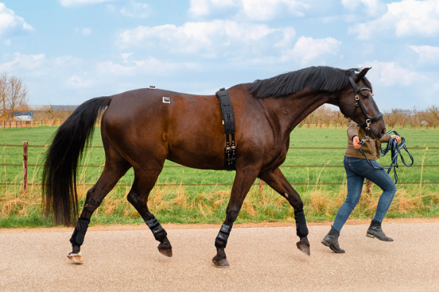By measuring the details of a person’s gait, it is possible to gain insight into the micro-scale processes that are not physically observable and can not be measured directly. This approach is similar to the case in life sciences where the observation of the phenotype of an organism can be used to infer genotype. You have developed the knowledge and skills to measure the macroscopic movement during gait using accelerometers and gyroscopes. As our observation tools become more precise and our data sets become larger, our ability to infer microscale details from our macroscale observations will become more and more impactful. Applications range from general health monitoring, detection of neurological conditions, recovery following medical interventions, or even the optimization of performance in sports. In addition to measurement of the human gait, similar applications are being pursued in animals, providing valuable opportunities to improve animal healthcare and improve the understanding of their underlying biology.

A diagram of the human gait cycle is provided below. This diagram and the associated terminology will allow you to make connections between the measured patterns in the acceleration and angular velocity with physical elements of the gait cycle. Watch this [video](https://www.youtube.com/watch?v=1u6d1CX7o9c) to familiarize yourself with the elements of the gait cycle.

**Pre-Lab Activity (30 minutes)**

The sensors in mobile devices such as smartphones and smartwatches are currently being used to monitor a person’s gait and provide valuable health information. Look for a fitness tracking or health application on your phone and investigate the data on mobility where parameters such as number of steps, step length, walking speed, and double support time are tracked. Watch the following video, made for Apple mobile application developers, that discusses the potential benefits of this technology and its implementation. You can skip the short sections on coding, but the overall process of developing such applications is useful to understand. [Beyond counting steps - WWDC20 - Videos - Apple Developer](https://developer.apple.com/videos/play/wwdc2020/10656)

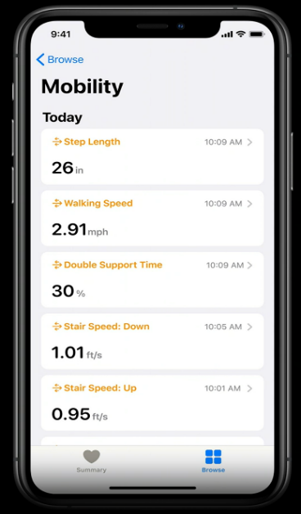

The integration of data from many sensors can help build a more complete picture of your health and fitness. Over time, the extraordinary data sets available from mobile MEMS sensors will provide even greater insight into the complexity of our human biology.

1. Create a “simple experiment” in phyphox for use in your gait analysis experiments. Choose to collect:

* Accelerometer
* Linear Acceleration
* Gyroscope

1. Use your simple experiment to collect 10 seconds of data while holding your phone in your hand or in your pocket while walking. Look at the data from all three sensors. The data will look complex. As we have done repeatedly, we should look for ways to simplify our experimental design. How might you adjust your experimental design for collecting sensor data on your gait that might help you better connect your observations to elements of the gait cycle and allow more effective analysis?
2. Include screenshots of your collected data from each sensor for your pre-lab activity upload.

**Experimental Guide**

In this experiment, you will use the accelerometer and the gyroscope in your smartphones to characterize your gait. As mentioned in the video and as you were able to see from your pre-lab experiment, the 3-axes accelerometer and gyroscope data is very complex. However, we know from our experience that the MEMS sensors are very precise, so within that complex data is detailed information on our movement and the underlying biological processes.

To simplify our analysis and discussion, we will use a common experimental design. To start, we will connect specific elements of the gait cycle to patterns in the data. Next, we will use numerical integration to extract more detail about the position and movement of our leg.

The research community is just beginning to understand all the potential health information that can be extracted from this type of data. The sensors in your phones and your analysis skills allow you to be part of that cutting edge medical science.

**Activity 1 – Collection of Gait Motion Data and Step Counting (120 minutes)**

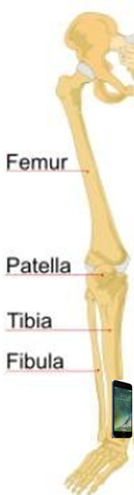Experimental Design

Identify a space where you can walk >20 steps in a straight line. Confirm you can secure the phone to your leg tightly at the location shown in the figure. Take special care to walk at a very uniform and repeatable cadence. Carefully measure the total distance of your walk.

*Sensor positioning:*

* Secure the phone tightly to the inside of right leg with the positive y-axis aligned along the tibia. (The phone should track the motion of your tibia and should not slip or slide while walking.)
* As precisely as possible, direct the positive z-axis inward, toward your left leg

*Measuring your movement as you walk:*

* Use the “simple experiment” you created in the pre-lab to collect motion data (accelerometer, linear acceleration, gyroscope)
* Use a timed run to collect data for the entire walk including a minimum of 1 second while stationary at the start and at the end
* Take your first step with your left leg (note this will be only a half-step)
* Take a total of 10 steps with your right leg (in the process you will take 9 full steps and two half steps with your left leg)
* Finish with your toes aligned at the end (you will end with a half-step with your left foot)
* Remain stationary at the end of your steps until data collection is completed.

1. *Collection of motion data:*  Collect your data using the experimental design outlined above. You may need to try the experiment several times to optimize your timing and pace. Show your instructor the results of your optimized experiment before moving on. Take screen shots for all three measurements (accelerometer, linear acceleration, and gyroscope). Include the screenshots below. Export your data for analysis in Excel. Keep the data in phyphox in case you want to go back to examine some graphs in more detail.
2. *Verify the orientation of your phone:* What data set can be used to determine the orientation of your phone at the start and end of the experiment. Explain.
3. *Analysis of Angular Velocity (z-axis) – Step Counting:* Create a graph of the z-axis angular velocity in Excel. Insert a graph for the entire experiment below.
   1. Examine the pattern and identify on the graph the approximate time for each step of the right foot (use labels of R2, R4, R6, …) and left foot (use labels of L1, L3, L5, …).
4. *Analysis of Angular Velocity (z-axis)* – *Gait Cycl*e: Create a graph in Excel of the z-axis angular velocity where the time axis has been adjusted to show ~2 steps.
   1. On the graph, indicate the time of each right foot heal strike. Explain how you made that determination.
   2. On the graph, identify and label the time frame for one complete gait cycle.
5. *Analysis of Angular Velocity (z-axis)* – *Angular Displacement:* Use numerical integration to determine the angular displacement for the z-axis for the entire duration of your experiment. Insert a graph of the angular displacement (include both the angular velocity and the angular displacement if you are able to use a secondary axis).

* 1. 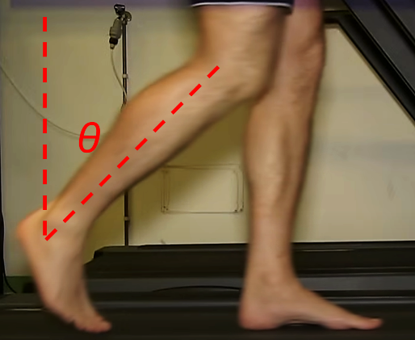From your data, can you determine the maximum average angle of your right leg during walking as indicated in the figure? Provide the angle with units of degrees.

* 1. Look at the angular velocity for the y-axis. What information does it provide on a walker’s movement? Describe.
  2. A picture containing tree, outdoor, forest, plant

     Description automatically generatedYour x-axis angular velocity likely has the lowest magnitude. Explain. Do you think the x-axis angular velocity might indicate a person is walking on irregular terrain or potentially enable detection when someone twists an ankle?

1. *Analysis of Linear Acceleration (y-axis):* Examine the y-acceleration without g (linear acceleration) in phyphox.

* 1. Include a screenshot of the expanded graph and indicate the time where your right foot is firmly on the ground.

1. *Analysis of Linear Acceleration (x-axis):* When a person walks, their feet only come a few centimeters off the ground. Let’s evaluate if the acceleration along the x-axis can provide a useful measure of the velocity and displacement along the direction of walking.
   1. Determine the velocity and the displacement from the x-axis acceleration. Remember to determine the offset before conducting the numerical integration. Graph the linear velocity and linear displacement (include the linear acceleration if you are able to use a secondary axis). Insert your graph below.
   2. How does the measured displacement compare to the displacement you experimentally measured? Is this a useful method for measuring distance traveled if GPS was not available?