Exploring Acceleration: Activity 3
Characterizing the Motion of an Elevator

Name:______________________ Date:____________ Period:_____

Hypothesis: The measured acceleration of an elevator during transit can be used to determine the velocity and height traveled as well as evaluate the operational performance of the elevator.

Guiding Questions:
Introduction: There are on the order of 1 million elevators in the United States that enable approximately 20 billion passenger trips a year. Some of you might become involved in the ~$100 billion/year industry and everyone is likely to benefit from the convenience of elevators. Elevators also provide an excellent opportunity for exploring motion for physics students.

- Discuss what you “feel” during a ride on an elevator. Do you feel a different force at the start, middle and end of the ride? Does your experience feel different on the way up than on the way down? (If you have not been on an elevator, image what is happening and try to determine what you might expect to feel.)

- Estimate the maximum velocity of an elevator that you have used recently. Explain how you made your estimate.

Goals:
- Explore the acceleration of a common machine and connect the qualitative “feel” of a common experience to quantitative measurements and analysis.
Instructions:
- Measure the acceleration going up or down in an elevator
  - Identify an elevator where you can make your measurements or ask your teacher to provide you with experimental data.
  - Use the acceleration without g on the phyphox application
  - Hold the phone in a stable position against the wall of the elevator during the ride to assure that it is stable.
  - Collect data while riding the elevator. Make sure to get several seconds of data prior to movement and after stopping. Export your final data set for analysis.

- Graphing and analysis of the acceleration data
  - Open the spreadsheet with your raw data and create a new sheet.
  - Transfer the time and acceleration data for the primary axis into the new sheet.
  - Create a graph of acceleration vs time. Sketch or insert the graph below.
  - Describe how the different regions of the acceleration data are related to the physical movement of the elevator. Discuss what is happening when there are changes in the acceleration and what is happening when the acceleration is zero at different times during the “ride”.

  - Calculate the velocity at each point in time from the acceleration and time data. Create a graph that contains both acceleration and velocity. Insert the graph below.

  - Calculate the displacement at each point in time from the velocity and time data. Create graph that contains both the velocity and the displacement. Insert the graph below.

Analysis and Discussion:

- Consider your acceleration vs time graph. Sketch what you expect an acceleration vs time graph would look like if you were going in the opposite direction from your experiment.

- Did your data show a period of constant velocity as the elevator traveled between floors? Could you predict the time where the elevator would be traveling at constant velocity by visually inspecting the acceleration vs time graph? Explain.

- How did the maximum velocity you measured compare to your prediction?

- A 70 kg person is standing on a scale during an elevator ride going down. During the first few seconds of movement the scale should read:

  - <70 kg b. ~70 kg c. >70 kg

- A 70 kg person is standing on a scale during an elevator ride. During the time the elevator is moving at constant velocity, the scale should read 70 kg regardless of the direction of travel.

  - True b. False

- A 70 kg person is standing on a scale during an elevator ride going down. During the final few seconds before the elevator stops, the scale should read:

  - <70 kg b. ~70 kg c. >70 kg

- Using your experimental data, estimate the average height for each floor of the building used in your experiment. How does your value for average floor height compare to data you can find on the internet?

Extension Questions:
- Did you measure vibrations that occurred during the movement of the elevator? Do you think it would be possible to use acceleration measurements to monitor the performance of the elevator or to identify if the elevator needs maintenance? Explain how you might use this information.

- Do you think that the number of people in an elevator impact the movement? What affect do you think additional mass in the elevator might have on the movement?

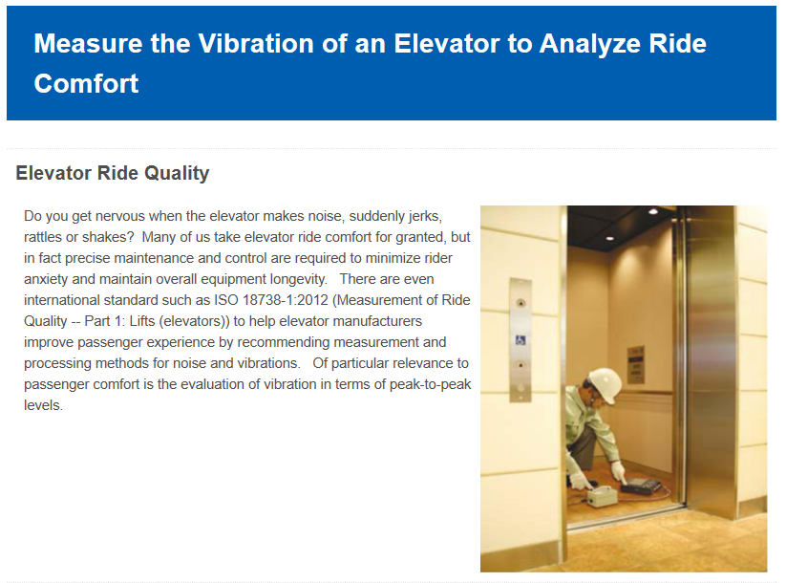
This guy might consider using his phone.

