Exploring Acceleration: Activity 4
Determining the Acceleration of Gravity by Measuring Free-Fall Times

Name:______________________ Date:____________ Period:_____

Hypothesis: An accelerometer sensor on a phone can be used to accurately determine the acceleration due to gravity by measuring the free-fall time of the phone over known distances.

Guiding Questions:
Introduction: Everyone has observed the acceleration of objects as they fall. If you were asked to catch a 1 kg rock dropped from 20 cm you probably would be willing to accept the task. If you were asked to catch the same rocked dropped from 10 m above you, you might not be such a willing participant in the experiment. You know from experience that the rock will be moving much faster after falling 10 meters. There is clearly a force continuously acting on the rock resulting in an acceleration, even though it does not appear that anything is touching it.

- What is the force which causes the acceleration of a “falling” rock? What do you think determines the magnitude of the force? What do you think determines the direction?

- You may have seen video of people on the international space station or people walking on the moon. Why is the force acting on them different than the force we feel on the surface of Earth?

- Motion resulting from the constant acceleration due to gravity is often called “free-fall”. Motion during free-fall can be described by the following equation:
$$∆d= v_{i}t+ \frac{1}{2}gt^{2}$$
where the change in position of an object is equal to the sum of the product of the initial velocity and the free-fall time plus half the product of the acceleration due to gravity and the square of the free-fall time. If the object is initially at rest (i.e., v_{i} = 0), it is possible to calculate the acceleration due to gravity when we measure the change in distance and time. Finish solving the equation for g below:
$$g=$$

Goals:
- Explore the direct measurement of gravity using a 3-axis accelerometer.
- Investigate the absence of a gravitational force in the reference frame of a free-falling object by observing the response of an accelerometer.
- Use the equations of motion and the free-fall time, determined from the measurement of acceleration, to calculate g.
Warmup Activity:
  - Using the phyphox app, select the “acceleration with g” and choose the simple display mode. Set your phone on a flat surface and record the value the sensor provides for the absolute acceleration due to gravity.

Measured value of g: ______________

Expected value of g:_______________

  - Using “acceleration with g”, observe the acceleration due to gravity along the three individual axes as you change the orientation of your phone. While holding you phone in the three orientations shown below (attempting to maximize the acceleration along one axis and minimizing it along the other two axes), record the measured acceleration along each axis.

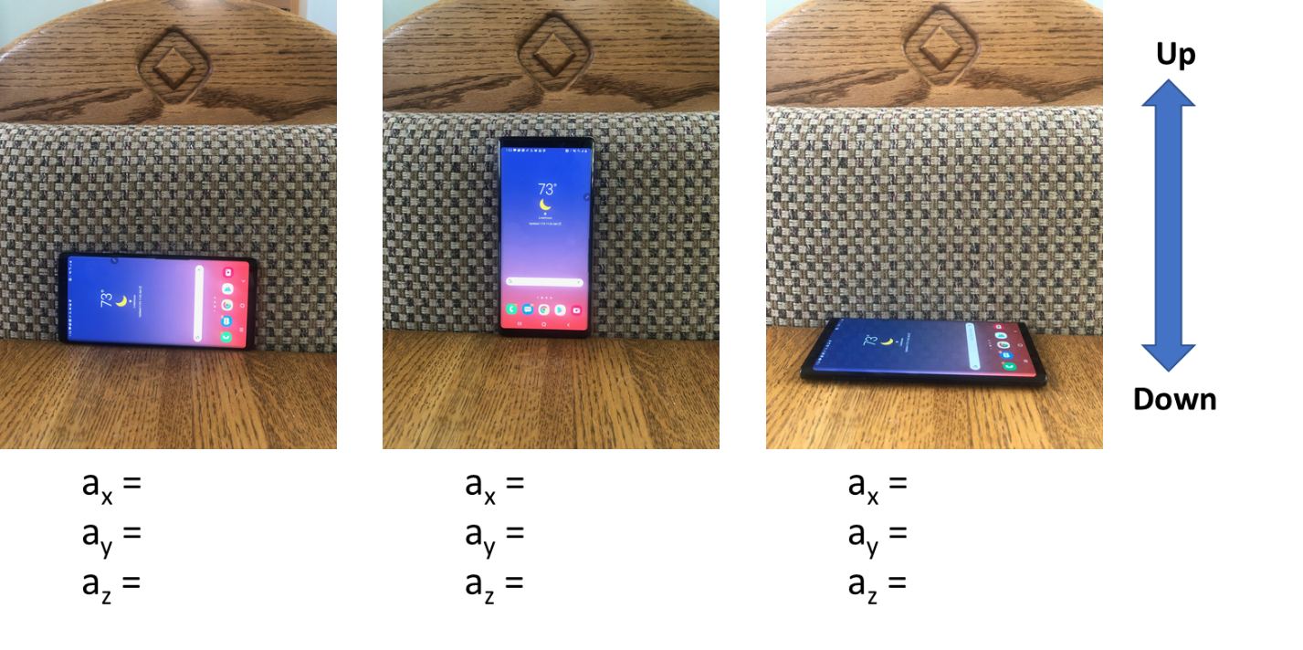

  - Test your knowledge of the orientation of your accelerometer sensor. Reproduce the diagram below and paste you best effort to reproduce it to the right of the original.

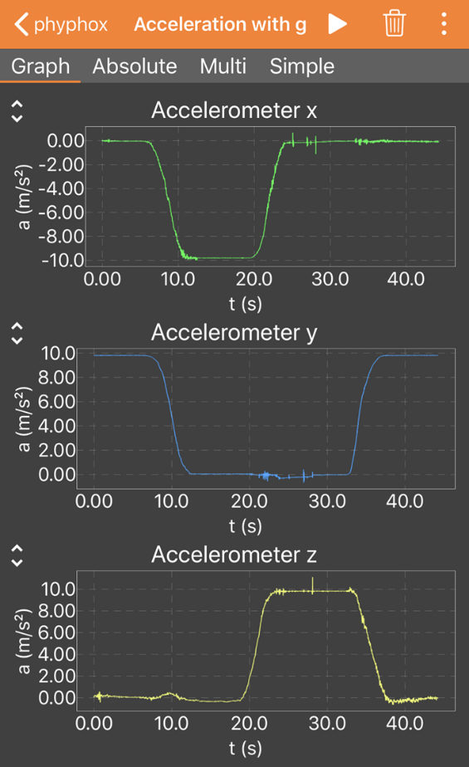

  - As you can see, the accelerometer is very sensitive and provides a precise measurement of the orientation of your phone. One of the reasons for having accelerometers in your phone is to enable your phone to sense orientation for a wide range of applications. Select and view the y-axis while you move your phone like it is a game controller for 10 seconds. Expand the scale and see how well it captured quick movements. How well does the accelerometer capture your fastest movement? Do you think your need a faster sensor or does the sensor collect data fast enough to completely capture your movement? Explain.

Instructions:
- Observe the accelerometer response when your phone is in free-fall using “acceleration with g”
  - Drop your phone from one hand into the other or onto a soft surface. BE VERY CAREFUL!
  - Allow the phone to be in free-fall for ~20-30 cm.
  - Drop on different axes and investigate the effect of rotation.
  - Include a screenshot or diagram that illustrates the response of the 3 accelerometer sensors during free-fall.

- Measure the free-fall time for a displacement of ~1 meter
  - Assure that your phone lands on a relatively “soft” surface that also will produce a well-defined accelerometer response upon contact (e.g., a mattress or sofa cushion).
  - The distance does not need to be exactly 1 meter, but the distance should be measured with <1 cm accuracy.
  - Practice several drops to perfect your method trying to assure that your release is as “immediate” as possible and that there is minimal rotation of the phone.
  - The measurement of the free-fall time needs to be very accurate so think carefully about which data points will best indicate the start and end of the free-fall. (The time should be marked by the first indication of a change in acceleration for the drop at the start and for the collision at the end.)
  - Conduct 3 trials and fill out the table below.

Trial | D (m) | Start time (s) | End time (s) | Total time (s) | Calculated value for g (m/s²)
1
2
3

  - Determine the average value for g from your data.

Average measured value of g: ________________

  - Using the following site: determine the expected value of g at your location. https://www.ngs.noaa.gov/cgi-bin/grav_pdx.prl

Expected value of g: ________________

  - Calculate the percentage error of your measurement relative to the expected value.

- Determine the value of the acceleration due to gravity graphically by observing the free-fall times for a series of distances
  - Using the method from part 2 of this activity, make two measurements at 5 different heights between 0.2 m and 1.5 meters.
  - Create a data table for your data and include it below:

  - Graph height vs free fall time. Include the graph below:

  - Graph height vs square of the free-fall time. Include a best fit to the data and determine g from the slope of your graph. Include the graph below:

Analysis and Discussion:

- In part 1 of this experiment, you observed that all three accelerometers read zero during free-fall. Explain your observation.

- Discuss the accuracy of your measurement in part 2. What were the potential sources of error? Suggest an experiment you might perform or an analysis you could conduct to evaluate the importance of the one of the sources of error?

- In part 3 of this experiment, you determined the value of g graphically. Discuss the merits of this method and compare it to the measurement conducted at a single height (part 2).

- Using your knowledge of free-fall, sketch the following graphs for free-fall on Earth (ignoring air resistance).

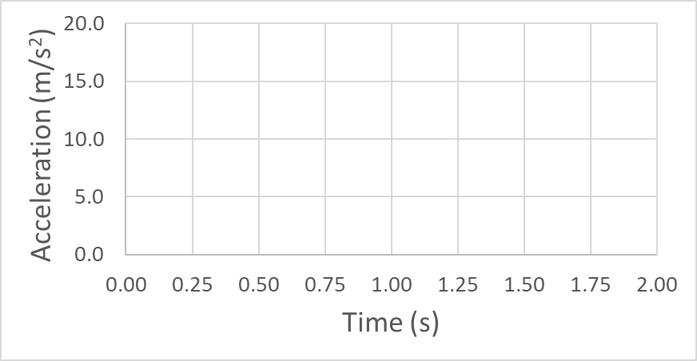

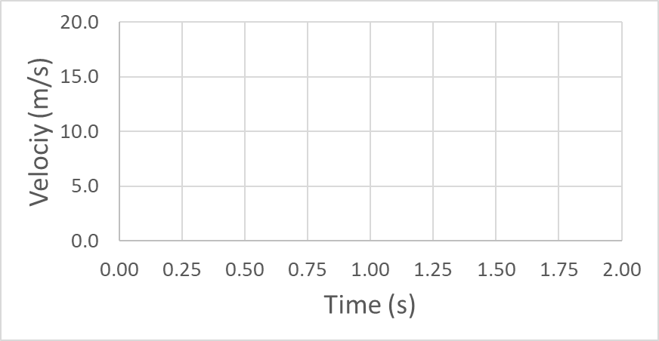

Extension Questions:
- In our experiments we ignored the force that can result from air resistance which is often called the drag force. This was probably a good assumption for our low velocities and the relatively high mass of our phones. However, as a falling object reaches higher velocities the drag force from air becomes larger. Eventually the drag force and the force from gravity become equal. When the net force on the object is zero, the acceleration is also zero and the velocity is constant. This final constant velocity is called the terminal velocity. Use your physical intuition to complete the following equation for terminal velocity using the quantities provide below. Think about what will increase or decrease the terminal velocity and replace the question marks with the appropriate variable when you rewrite the equation below.
$$terminal velocity= \sqrt{\frac{2 x ?x ?}{? x ? x C_{d}}}$$
C_{d} – drag coefficient
m – mass
g – gravity
ρ – density
A – projected area

- Based on the equation of terminal velocity, we can state that the square of the terminal velocity is directly proportional to:
  - mass b. gravity c. density d. projected area

- Based on the equation of terminal velocity, we can state that the square of the terminal velocity is inversely proportional to:
  - mass b. gravity c. density d. projected area

- A sky diver recorded her acceleration using the “acceleration with g” sensor application during her jump. What acceleration do you expect she would feel at the various times during her jump? Estimate the acceleration you might expect and sketch it on the graph below. (Concentrate on the direction of change and not the absolute values.)

