Exploring Friction and Mechanics: Activity 2
Variation of the Coefficient of Kinetic Friction with Surface Properties

Name:______________________ Date:____________ Period:_____

Hypothesis: The coefficient of kinetic friction is dependent on the properties of the two contacting surfaces and the magnitude is dependence on both the physical roughness and the material properties of the surfaces.

Guiding Questions:
Introduction: The macroscopic and microscopic interactions that are responsible for frictional forces are still an active area of research. The ability to reduce or increase friction is a very important for engineering systems (e.g., tires, shoes, snowboards, machines) as well as for the natural world (e.g., feet, skin, joints).

- Do you think that the “smoothness” of a surface will always lead to a lower coefficient of friction? What surfaces might you include in a study to test this hypothesis?

- How might thin layers of fluids at the surface of solids influence the coefficient of friction?

Goals:
- Enable inquiry-based exploration of important phenomena in physics (friction forces) using a very simple experimental design.
- Develop skills in conducting iterative design and test process to optimize an experimental design.
- Develop a conceptual model of the macroscopic and microscopic contributions to frictional forces through direct observation of different material interactions.

Instructions:
- Measure the coefficient of friction for 5 different surface combinations
  - Consider using either the “hand sliding” (used in the warmup for Activity #1) or the rubber band method. Use the method that you believe will give you the most reproducible and accurate results (both methods have some advantages/disadvantages).
    - Try to change some of the variables that you are assuming are not changing the experimental results (e.g., the distance of the slide, specific location on the surface where you slide you phone, the orientation of your phone, …). Decide on the best experimental design.
    - Decide how you will determine the “average” acceleration used in your calculations.
  - For one of the surface combinations, repeat the measurement multiple times using your optimized experimental design (you can decide how many measurements you think are necessary). You will use this set of measurements to determine the precision of your method.
  - Decide on the surface combinations you want to investigate and conduct your experiment for each surface. Decide how many repeated measurements are required to assure accurate determination of the coefficient of friction for each of the surface combinations.
  - Create a table to summarize all your data including the coefficient of friction for each surface combination. (Include all the information that another scientist would want to see if they wanted to understand your experiment.)

Analysis and Discussion:

- Describe your method for measuring the acceleration due to friction of your sliding phone. Discuss how you decided on the method and describe the experiments you conducted to determine you were achieving reproducible results.

- Describe how you determined the precision of your method. Quantify the precision of your measurement. (Do this in your own way or use standard statistical methods if you have experience with them.)

- Discuss the range of values for the coefficients of friction you measured. Did you observations support your original answer to Guiding Question #1?

- Create a graphic that illustrates the different values for the coefficients of friction you measured. You can decide the best format to use that allows you to clearly communicate your results. Present a summary of your results to your classmates using this graphic.

Extension Question:
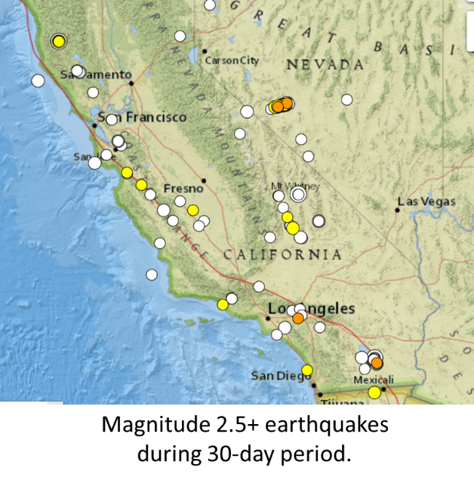
Before an earthquake, static friction helps hold the two sides of a fault immobile and pressed against each other. During the passage of an earthquake rupture, that friction becomes dynamic as the two sides of the fault grind past one another. Dynamic friction evolves throughout an earthquake, affecting how much and how fast the ground will shake and thus the destructiveness of the earthquake. Scientists continue to refine their models as we continue to make measurements of the accereration of the ground at different locations during earthquakes and combine that with our growing knowledge of the geology of the region.

Do you think the types of rocks and fluids around the rocks will make a difference? Make a hypothosis based on the understanding you have developed in this experiment. Discuss how different values of static and dynamic friction might impact the magnitude and how energy is released in an earthquake.

