Mechanical Waves and Sound: Activity 4
Determining the Speed of Sound in Air
Name:______________________ Date:____________ Period:_____

Hypothesis: The speed of sound in air can be determined, by measuring the transit time of a well-defined sound wave between two locations.

Guiding Questions:
Introduction: Measuring the speed of an object or a wave, requires using an experimental design and measurement tools that have appropriate accuracy for the speed of interest. In this activity, you will be determining the speed of sound in air through a series of experiments which have increasing levels of accuracy.
- Consider a 100-meter race at a high school track meet that is started by a loud noise. Describe how an official timer using a stopwatch would determine how long a runner takes to complete the race (this question is as simple as it sounds).

  - What assumption is made about the speed of sound and the speed of light relative to the speed of the runners?

  - If the speed of sound waves were 10 m/s (it is not this slow), how would that impact the start of the race? Would the position of runners relative to the location where the starting sound originated make a difference?

  - Would it be possible to fairly start a race using sound if sound waves traveled at 10 m/s? Explain how this might be accomplished.

  - How might the visual or auditory reaction time of the person starting and stopping the timer impact the precision of the measurement?

- Consider experiences that you have experienced or observed that could be used to compare the relative speed of light and sound. Describe your observations.

  - If the speed of light is 3 x 10⁸ m/s, make an estimate of the speed of sound based on your observations. Explain how you made your estimate. Don’t worry about being wrong, we will get to accurate measurements in the remainder of this activity.

Goals:
- Determine the speed of sound and develop a physical sense for the speed at which sound travels relative to macroscopic objects which are typically slower and electromagnetic waves such as light which are much faster.
- Develop physical connections between the microscopic movement of molecules and the macroscopic properties of mechanical wave.
- Gain experience improving experimental designs by devising ways to make measurements of increasing accuracy and precision.
- Develop an understanding of the very fast pressure oscillations associated with sound waves and the use of a microphone to measure the signals at very high rates compared to any other sensors students have used previously.

Instructions:

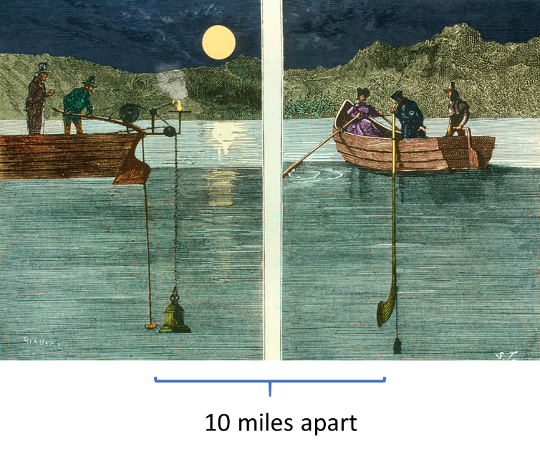
- In 1826 on Lake Geneva, Switzerland, Jean-Daniel Colladon, a physicist, and Charles-Francois Sturm, a mathematician, made the first recorded attempt to determine the speed of sound in water. In their experiment, an underwater bell was struck simultaneously with ignition of gunpowder on the first boat. The sound of the bell and flash from the gunpowder were observed 10 miles away on the second boat. The time between the gunpowder flash and the sound reaching the second boat was used to calculate the speed of sound in water. At 8 °C, they determined the speed of sound in fresh water to be 1435 meters per second (the current accepted value is 1438 m/s).

Using the experimental approach of observing an event and measuring the delay of the sound wave over a known distance, design an experiment to measure the speed of sound in air. You can use the stopwatch on your phones, a sports field or section of road of known length and your choice of how to make the sound wave (not gunpower).

Describe your experimental design:

Record your data in this table:

Trial | Distance | Time | Speed of Sound
1
2
3
 |  | Average =

- The acoustic stopwatch application in phyphox uses changes in the microphone signal to start and stop a timer. This electronic signal processing removes the imprecise reaction time of humans, a source of error in the previous experiment. Implement the experimental design below to measure the speed of sound.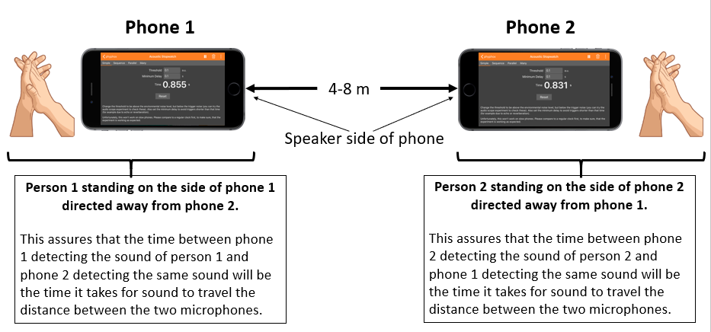

    - Explore the acoustic stopwatch application. Learn how it works and how to set the threshold to start and stop the timer.
    - Separate the microphones on two phones by 4-8 meters and position experimentalists as shown in the diagram (this experiment works best with a partner).
    - Prepare the acoustic stopwatch for data collection. Have individual 1 (next to phone 1) make a loud noise (clap, bang blocks, clang metal, …) followed by individual 2 (next to phone 2) making a similar loud noise.
    - The acoustic stopwatch provides the time interval between the two sound waves as sensed by each of the microphones. The difference between the times measured by the two microphones will be the time it takes sound waves to travel 2x the distance between them.
    - Complete 4 trials of the measurement and record your data in the table below. Make sure to record the temperature.

Trial | Time1 (s) | Time2 (s) | Δt (s) | 2 x Distance (m) | Speed of Sound
1
2
3
4
 |  |  |  | Average =

Temperature = _______

Analysis and Discussion:

- The speed of sound in air should be approximately 340 m/s depending on the temperature. Was the speed of sound you determined in part 1 within a factor of two of the expected value?

  - How many orders of magnitude slower is a sound wave compared to light?

- In your initial experiment, you relied upon visual and auditory reaction times to start and stop a timer. A typical human reaction time is approximately 200 ms. How far does a sound wave travel in the time it takes a person to react?

  - Discuss how this error might impact your measurement if there was a 25% variation in your reaction time in starting and stopping the timer.

  - How could you improve your measurement accuracy and precision of this experimental approach if you continued to depend on using a person to stop and start the timer?

- In the experiment using the acoustic stopwatch, explain why the difference between the times on phone1 and phone2 was the time it took a sound wave to travel twice the distance between the phones. Use a diagram if you desire.

  - The instructions for the experimental design were explicit on where to make the noise relative to the position of the phone. Would it matter if the phones were place on the floor and a person stood behind the phones and clapped in front of their chest to trigger the acoustic stopwatch timers? Explain.

  - The acoustic stopwatch provides timing with a resolution of 1 ms. Calculate the percentage error that is introduced to your experiment by a 1 ms change in the Δt measurement.

- Calculate the speed of sound for the temperature of your experiment. Then calculate the percentage error from the average value of the speed of sound determined using the acoustic stopwatch method.
$$Calculated Speed of Sound=331.3+0.606 \left(T in °C\right)=$$

  - The speed of sound increases with temperature. Using your understanding of thermodynamics and the kinetic energy of molecules, provide hypothesis of why the speed of sound increases with temperature.

  - You have probably heard people talk “funny” when they inhaled helium before speaking. How would you expect the speed of sound to change in helium gas relative to air which is composed primarily of oxygen and nitrogen molecules?

- Do you expect the amplitude of a sound wave will change the speed of sound in a medium? You have already made observations that provide evidence to answer this question when conducting your experiments. Explain.
Extension Question:

The two graphs below show the pressure fluctuations associated with the sound wave produced by a clap. The first graph is on a 1 second time scale and the second is on a 4 ms time scale. As you can see, there is a tremendous amount of detail measured by the microphone.

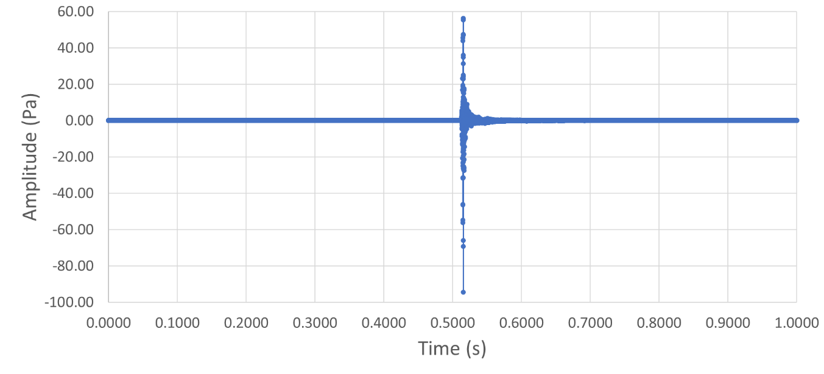

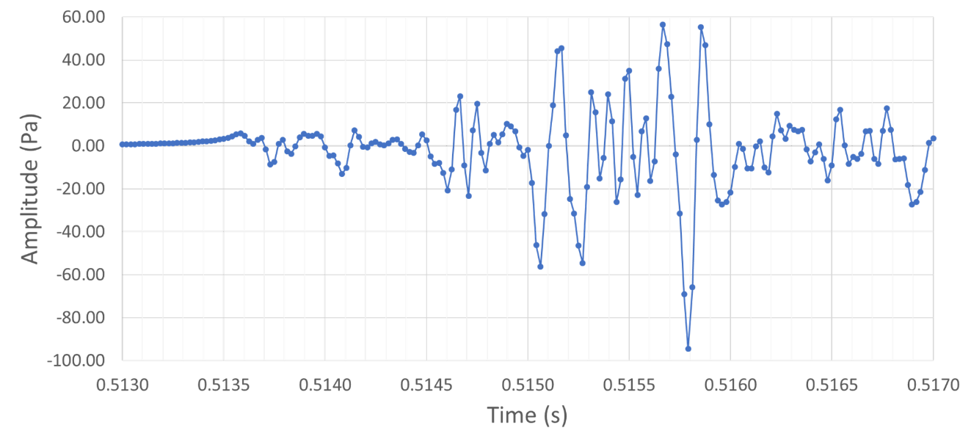

- Estimate the data collection rate from this figure. ___________ Hz

- The acoustic stopwatch starts the timer once it detects a signal from the microphone that reaches a certain threshold value. Is there a clear time that you believe indicates the start of the sound wave? Indicate where you think the acoustic stopwatch might have been triggered.

  - Explain why your think a clap might result in such a complex pressure fluctuation.

- The figure below is the pressure fluctuation measured by a microphone for the collision of two solid plastic blocks colliding (corner of one block into the surface of the second). Note the time scale is 4 ms.

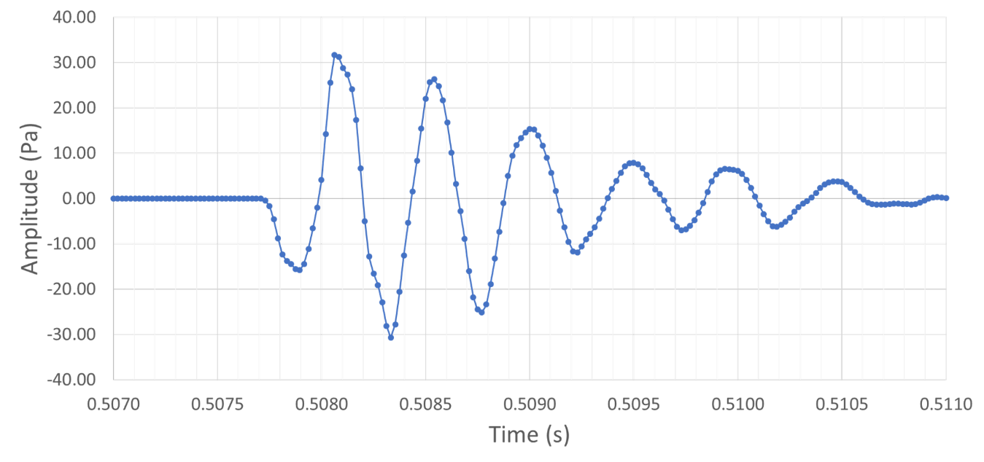

  - How accurately are you able to determine the onset of this sound wave?

  - Calculate the percentage error that you would expect the uncertainty in measuring time would contribute to the speed of sound measurement if you were to use this method of generating sound. (Similar to what you did in the 3b of the Discussion and Analysis section.)

Using well defined sound waves and the raw microphone data (replacing the acoustic stopwatch), the speed of sound can be determined with very high accuracy using the experimental design described in this activity. This is left for the ambitious student to try.

