Understanding Motion: Activity 2
Graphing Data in Spreadsheets: Latitude/Longitude vs. Time

Name:______________________ Date:____________ Period:_____

Hypothesis: Learning to create graphs using spreadsheets is a valuable skill for all scientists/engineers and will be helpful for anyone who might need to communicate or understand scientific information. (We will not prove this hypothesis in this activity, but we will proceed under the assumption this is true.)

Guiding Questions:
- What is the purpose of including a chart (graph) of your data?

- What type of chart would be best in illustrating how latitude and longitude change with time?
Scatter/Line Bar/Column Circle/Pie
Goal:
- Develop skills to quickly create scatter/line charts, using spreadsheets, to display large data sets that are common in scientific measurements. This skill will be routinely used in analyzing data from “phone physics” experiments.

Warmup/Preparation Activity:
- Watch the following video as an introduction to using spreadsheets in physics. https://www.youtube.com/watch?v=WRPH7Rv_LmQ

Instructions:
- If you did not save the data from the previous activity, you will need to repeat it. Be sure to export your data to your preferred spreadsheet program. Nearly all spreadsheet programs have the same basic functionality, but the placement of buttons and editing tools will be different. Screenshots presented here are from Google Sheets.

- While it is possible to create charts based on the raw data directly exported to your spreadsheet, it is always a good idea to leave the raw data alone and copy the data to a new sheet for analysis. Create two new sheets and call them “Longitude Data” and “Latitude Data” using the function indicated by the red circle in the figure below.
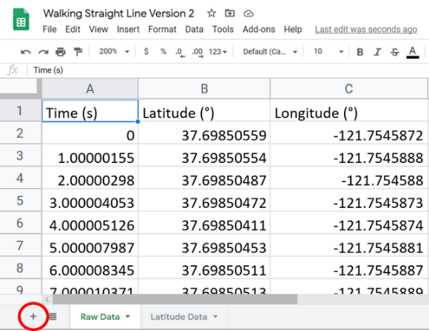

- Go back to your Raw Data sheet and click on the ‘A’ Column; this should select the entire column of data:
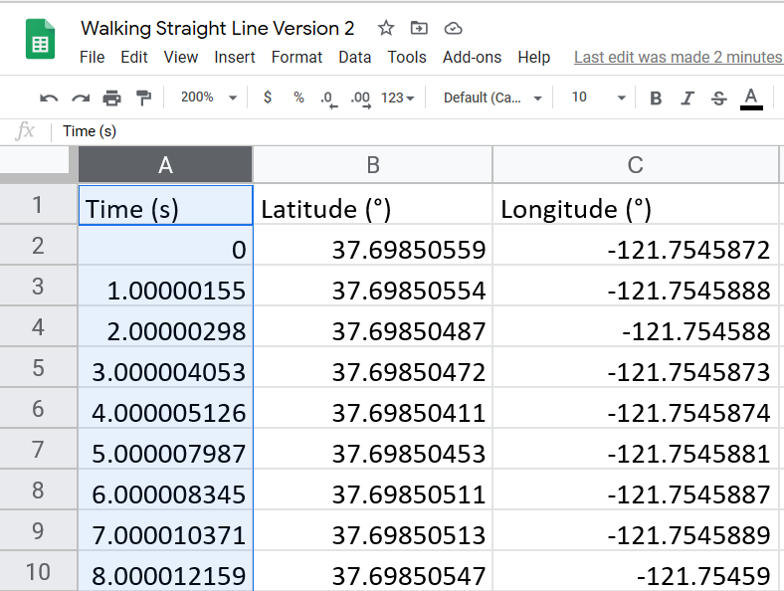
- Copy this and paste it into column A of both of the sheets you created in step b.
- Now copy the Latitude column (should be column B) and paste it into column B of your Latitude Data sheet. Do the same for your Longitude data (should be column C in your Raw Data sheet), also pasting it into column B of your Longitude Data sheet.
- On your Longitude Data sheet, select all of the data in both columns. This is easily done by clicking and dragging from column A to column B (make sure column A is not selected first, or you will move it).
- With that data selected, create your chart and using the insert chart function.
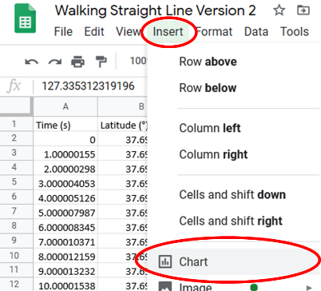
- Chances are that one or more things are not quite right about your chart. It is now time for you to explore the chart editor to create the chart you desire with appropriate axis variables, axes scales and axes labels. (Take you time on this step as it will be a skill that you will use repeatedly. If you are having trouble, go back to watch the recommended video or find other appropriate videos for your spreadsheet program.)

- Complete steps f-h again on the Latitude Data sheet.
- The final step in assuring effective communication of your results to others is to include some additional information with your graph. This can be done by pasting your graph into a presentation program like PowerPoint or Google Slides. Your final product might look something like the graphic below.

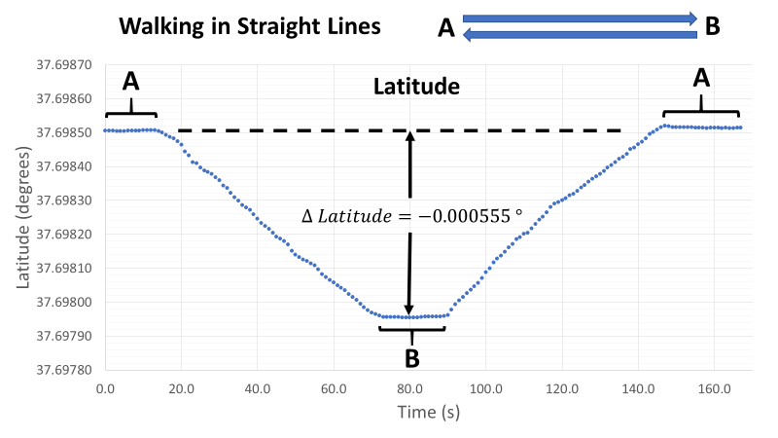

Extension Question:
If is often very useful to plot two data sets on the same graph that have very different scales. Create a graph that includes both latitude and longitude measurements on the same graph. Use a secondary axis for the longitude data. (You saw an example of a graph using two axes in the extension question in Activity 1.)

